Preparation of Papers in a Two-Column Format for
SICE 2015 with Word File
Taro Keisoku^{1†} and Hanako Seigyo²
¹Department of Xxx, University of Xxxx, Tokyo, Japan
(Tel : +81-2-000-0000; E-mail: taro@xxx.ac.jp)
²Department of Yyy, Yyyy University, Tokyo, Japan
(Tel : +81-3-000-0000; E-mail: hanako@yyyy.ac.jp)

Abstract: This template provides a sample format of final manuscripts for SICE 2015. It also provides instructions to authors for completing the final manuscripts which will be included in the conference Proceedings. This template is available for both Regular paper and Position paper.

Keywords: Selected keywords relevant to the subject.

1. INTRODUCTION
Each paper must be divided into two parts. The first part includes the title, authors' name, abstract and keywords. The second part is the main body of the paper.
2. PAPER SIZE AND FORMAT
The size of the manuscript must be A4 and should be typed in two columns with single spacing. The standard length of the regular papers is 6 pages, while that of position papers is 4 pages. Up to two extra pages are permitted. For each page exceeding the standard length, overlength page fee will be charged. See conference website for detail.
Left margin 20mm
Right margin 20mm
Top margin 25mm
Bottom margin 25mm
Column width 80mm
Submitted papers MUST BE in Portable Document Format (PDF). NO OTHER FORMATS WILL BE ACCEPTED. The size of the PDF file to be sent electronically should not exceed four megabytes (4 MB), regardless of the number of pages.
3. Fonts and style
4.1 First part
The first part includes the paper title, authors’ name, abstract, and keywords, all of them in Times Roman or similar font. The font size of the title, authors’ name, affiliation, abstract, and keywords are bold 12pt, 11pt, 10pt, 10pt, and 10pt, respectively.
4.2 Paper body
The second part consisting of the body of the paper must be edited in double column format, with each column 80mm width and separated by 10mm. The top-level heading, usually called section, numbered in Arabic numerals, shall appear centered on the column with Times Roman capital bold 11pt. The numbered level-two heading starts from the left in Times Roman bold 10pt font. The main text uses Times Roman 10pt font with single spacing. The first line of a new paragraph is indented by 4mm.
† Taro Keisoku is the presenter of this paper.

4. Figures, tables, and equations
4.1 Figures and tables
All figures and tables should be placed after their first mention in the text. Large figures and tables may span across both columns. Scanned images (e.g., line art, photos) can be used if the output resolution is at least 600dpi.

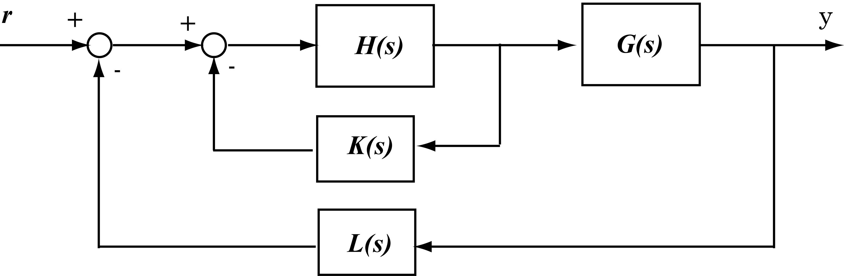
Fig.1 Caption should be placed below the figure.
Figure captions should be below the figures; table captions should be above the tables. They should be referred to in the text as, for example, Fig. 1, or Figs. 1 to 3.
Table 1 Caption should be placed above the table.
 | A | B | C
(1) | 150% | 16.3% | 18.2%

4.2 Equations
Equation numbers should be Arabic numerals enclosed in parentheses on the right-hand margin. They should be cited in the text as, for example, Eq. (1), or Eqs. (1) to (3). Equations start from the left of the column. Punctuate equations with commas or periods when they are part of a sentence. For example,
$\begin{matrix}\dot{x}=Ax+Bu, \\ y=Cx+Du,\end{matrix}$ (1)
where 𝑥 is the state vector.
4.3 References
References should appear in a separate bibliography at the end of the paper, with items referred to with numerals in square brackets [1, 3-5]. Times New Roman 10pt is used for references.
5. PAGE NUMBERS
Do not put page numbers in the manuscript PDF.
References
[1] CCC-SICE 2014 Website,
“http://www.sice.jp/ccc-sice2015/”
[2] T. Keisoku, “XXX Control of Nonlinear Systems”, International Journal of YYY, Vol. 99, No. 99, pp. 123-456, 2012.
[3] H. Seigyo, ZZZ Handbook, SICE, Tokyo, 2012
[4] T. Keisoku, “Measurement Method using ABC Sensor”, Transaction of EFG, Vol. 00, No. 1, pp. 1-9, 2012.
[5] H. Seigyo, “SSS Intelligent Systems”, International Journal of VVV, Vol. 12, No. 5, pp. 500-600, 2012.

