1. INTRODUCTION

Road construction and work on the water supply often require the relocation of aerial/underground telecommunication cables. Each optical fiber leading from an optical line terminal (OLT) in a telephone office to a customer’s optical network unit (ONU) must be cut and reconnected. Customers expect real-time transmission for high-quality communications to continue uninterrupted, especially for video transmission services.
Some electrical transmission apparatus can maintain communication without interruption, even when optical cables are temporarily cut. The system is complicated and any transmission delay during O/E conversion is fatal to real-time communication. Although it is desirable to directly switch the transmission medium itself, it had been thought that some data bits would inevitably be lost during the replacement of optical fibers. An optical fiber cable transfer splicing system [1] has been developed to minimize the disconnection time. It takes 30 ms to switch a transmission line, and more than 2 seconds ∗to restore communications with, for example, GE-PON [2].
We have developed an interruption-free replacement method for in-service telecommunication lines, which can be applied to the current PON system equipped with conventional OLTs and ONUs [3, 4]. Two essential techniques were presented; a measurement method and a system for adjusting the transmission line length. The latter continuously lengthens/shortens the line over very long distances without losing transmitted data based on free space optics (FSO). The former distinguishes the difference between the duplicated line lengths by analyzing signal interference. Interferometry is the technique of diagnosing the properties of two or more lasers or waves by studying the pattern of interference created by their superposition. It is an important investigative technique in the fields of astronomy, fiber optics, optical metrology and so on. Studies on optical interferometry are reported to improve tiny optical devices [5-7]. We have applied the technique to measure length of sevral kilometers of optical fibers with a 10 mm resolution.

Interruption-free Shunt System for Fiber Optics Transmission Line

Takeshi Tsujimura*, Koichi Yoshida*, Kuniaki Tanaka *, Kazunori Katayama*, and Yuji Azuma*

This paper studies a frame-loss-free shunt system for broadband optical fiber transmission lines. This system switches transmitting optical pulses between duplicated optical fibers to avoid any interruption to communication. A high-resolution measurement technique is necessary to evaluate the optical fiber length. We applied an interferometry technique to adjust 15 km duplicated optical lines at a resolution of 10 mm. An optical line switching system and procedure are designed for use in replacing in-service optical lines. A free space optics (FSO) system adjusts the length of an in-service optical line by up to 100 m. A gigabit ether-passive optical network (GE-PON) line is successfully replaced with an extended line while maintaining transmission.

Keywords: optical fiber, transmission line, interferometry, free space optics

This paper describes the design of our shunt system. An optical line length measurement method is studied to distinguish the difference of two lines by evaluating interfered optical pulses. An optical line switching procedure is designed, and a line length adjustment system is prototyped. Finally, we applied the proposed system to a 15 km GE-PON optical fiber network while adding a 10 m extension to show the efficiency of this approach when replacing in-service optical cables.

2. optical line switching SYSTEM

Figure 1 shows an individual optical line in a GE-PON transmission system. Optical pulse signals at two wavelengths are bidirectionally transmitted through a regular line between customers’ ONUs and an OLT in a telephone office via a wavelength independent optical coupler (WIC) and a 2x8 optical splitter (2x8 SP), respectively.
We have designed a shunt system, and a switching procedure for three wavelengths, namely 1310 and 1490 nm for GE-PON transmission, and 1650 nm for measurement. An optical line shunt system is installed in a telephone office. It is composed of an optical line length detector and an optical line length adjuster. A test light at a wavelength different from those of the transmission signals is sent from one of the optical splitter’s ports to the duplicated lines. An oscilloscope is connected to the optical coupler to detect the test light through a long-wavelength pass filter (LWPF). The optical line length adjuster is an FSO application. Some optical switches (SW) and optical fiber selectors (FS) control the flow of the optical signals managed by a PC. The optical pulses are compensated by 1650 and 1310/1490 nm amplifiers [8]

The proposed method temporarily provides a duplicate transmission line as shown in Fig. 1 to replace optical fiber cables. A detour line is prepared in advance through which to divert signals while the existing line is replaced with a new one. This system transfers signals between the two lines. Signals are duplicated at the moment of changeover to maintain continuous communications. The signals travel separately through the two lines to a receiver. A difference in the line lengths leads to a difference in the signals’ arrival times. A communication fault occurs if, as a result of their proximity, the waveforms of the two arriving signals are too blurred for the signals to be identified as discrete. Thus it is important to adjust the lengths of both lines precisely. Experiments determined that the tolerance of the difference in line length is 80 mm with regard to the GE-PON transmission system.
The proposed system controls the adjustment procedure so that the difference in length between the detour and regular lines is adjusted within 80 mm.

3. Optical LINE LENGTH MEASUREMENT

We use laser pulses at a wavelength of 1650 mm to measure the optical path length. They are introduced from an optical splitter, duplicated, and transmitted toward the OLT through the active and detour lines. They are distributed by an optical coupler just in front of the OLT, and observed with an oscilloscope. The conventional measurement method evaluates the arrival time interval between the duplicated signals, and converts it to the difference between the lengths of the regular line and the detour line at a resolution of 1 m.
The difference in line length, ΔL is described as

ΔL = c ∙ Δt / n, (1)

where c is the speed of light, Δt is the difference between the signal arrival times for the regular and detour lines, and n is the refractive index of optical fiber.
Figure 2 shows the received pulses observed with an oscilloscope. When the detour is 99 m shorter than the active line, pulses traveling through the detour line reach the oscilloscope about 500 ns earlier than through the regular line. The former pulse approaches the latter as shown in Fig. 2(b), while the system lengthens the detour line using the optical path length adjuster. This method fails if the difference between the line lengths is less than 1 m, because the two pulses combine as shown in Fig. 2(c).

We also developed an advanced technique for measuring a difference of less than 1 m between optical line lengths. Interferometry enables us to obtain more detailed measurements when the optical pulses combine. A chirped light source generates interference in the waveform of a unified pulse.

Each pulse, E (L_{j}, t) is expressed as

E (L_{j}, t) = A_{j} exp [ -i (k ∙n ∙L_{j} –ω_{j} ∙t +φ₀ ) ] , (2)

where j represents the regular line, 1, or the detour line, 2. And, A_{j}, k, n, L_{j}, _{j}, t, ₀ denote amplitude, wavenumber in a vacuum, refractive index of optical fiber, line length, frequency, time, and initial phase, respectively. The intensity of a waveform with interference, I, is calculated by taking the square sum as

Fig. 1 Shunt system of optical fiber transmission line.

I = | E (L₁, t) + E (L₂, t) | ²

= A₁²+ A₂² + 2 A₁ A₂ cos (k ∙n ∙ΔL – Δω ∙t) , (3)

where ΔL and Δω represent the differences between line lengths and frequencies, respectively.

The waveform with interference depends on the delay between the pulses’ arrival times. Time-domain waveforms are shown in Fig. 3. When the gap was 0.5 m, the waveform contained high-frequency waves as shown in Fig. 3(a). The less the gap became, the lower-frequency the interfered waveform was composed of. When the lengths of two lines coincided, a quite low-frequency waveform was observed as Fig. 3(d).

(a) 99 m apart
(b) 18 m apart
(c) 1 m apart

Fig. 2 Time-domain optical line length measurement when difference in line length is more than 1 m.
- 0.5 m apart

- 0.3 m apart

- 0.1 m apart

(d) 0 m apart

Fig. 3 Time-domain optical line length measurement when difference in line length is less than 1 m.

A Fourier-transform spectrum reveals the characteristics. When the gap was 0.5 m, the waveform with interference was composed of the power spectrum shown in Fig. 4(a). The peak power indicated that the major frequency component was around 600 MHz. Figure 4(b) and (c) indicate that the peak powers for gaps of 0.3 and 0.1 m were 360 and 120 MHz, respectively. It became difficult to determine the peak for smaller gaps, because the frequency peak became so low that it was hidden by the near direct-current part of the frequency component. When the lengths of duplicated lines coincided, the power spectrum was obtained as Fig. 4(d).

An evaluation of the frequency characteristics in the interfered waveforms showed that the peak frequencies are proportional to the difference between the line lengths from -1 to 1 m as shown in Fig. 5. This result helps us to determine the optimal position for adjustment. The optimal position where the line lengths coincide can be estimated by extrapolating the data.

(a) 0.5 m apart

(b) 0.3 m apart
(c) 0.1 m apart
(d) 0 m apart

Fig.4 Frequency-domain optical line length measurement.

Fig.5 Estimation of line length coincidence.

We have established a technique for distinguishing the difference between line lengths to an accuracy of better than 10 mm by analyzing interfering waveforms created by chirped laser pulses.

We have realized a complete length measurement for optical transmission lines from 100 m to 10 mm.

4. EXpERIMENTS ON Optical LINE replaceMENT

We designed a prototype of the optical line shunt system to apply to a GE-PON optical fiber line replacement according to the procedure described below.
An optical line length adjuster, shown in Photo 1, is installed along the detour line. The adjuster is equipped with two retroreflectors, which directly face each other as shown in Fig. 6. Optical pulses are transmitted through an optical fiber, divided into three wavelengths by wavelength division multiplexing (WDM) couplers, and discharged separately into the air from collimators. They travel 10 times between the retroreflectors, and are introduced into the other optical fiber. The number of reflections is determined based on the retroreflector arrangement.
The detour line between the retroreflectors consists of an FSO system [9]. The detour line length can be easily adjusted by controlling the retroreflector interval with a resolution of 0.14 mm.. Optical pulses travel n-times faster in the air than in an optical fiber, where n is the refractive index of the optical fiber. Thus the optical line length adjuster lengthens/shortens the corresponding optical fiber length, L

L = k W / n, (4)

where k, W, n are the number of journeys between the retroreflectors, the retroreflector interval, and the refractive index of optical fiber, respectively. The FSO lengthens the optical line length up to L₀.

L₀ = k (W_{max}- W_{min})/ n, (5)

where W_{max} and W_{min} are the maximum and minimum retroreflector intervals. The retroreflector stroke of our prototype, W_{max}- W_{min}, is around 0.3 m, the refractive index, n, of the optical fiber is 1.46, the number of journeys, k is 10, and the optical line span, L₀, tuned by the adjuster is 2 m.

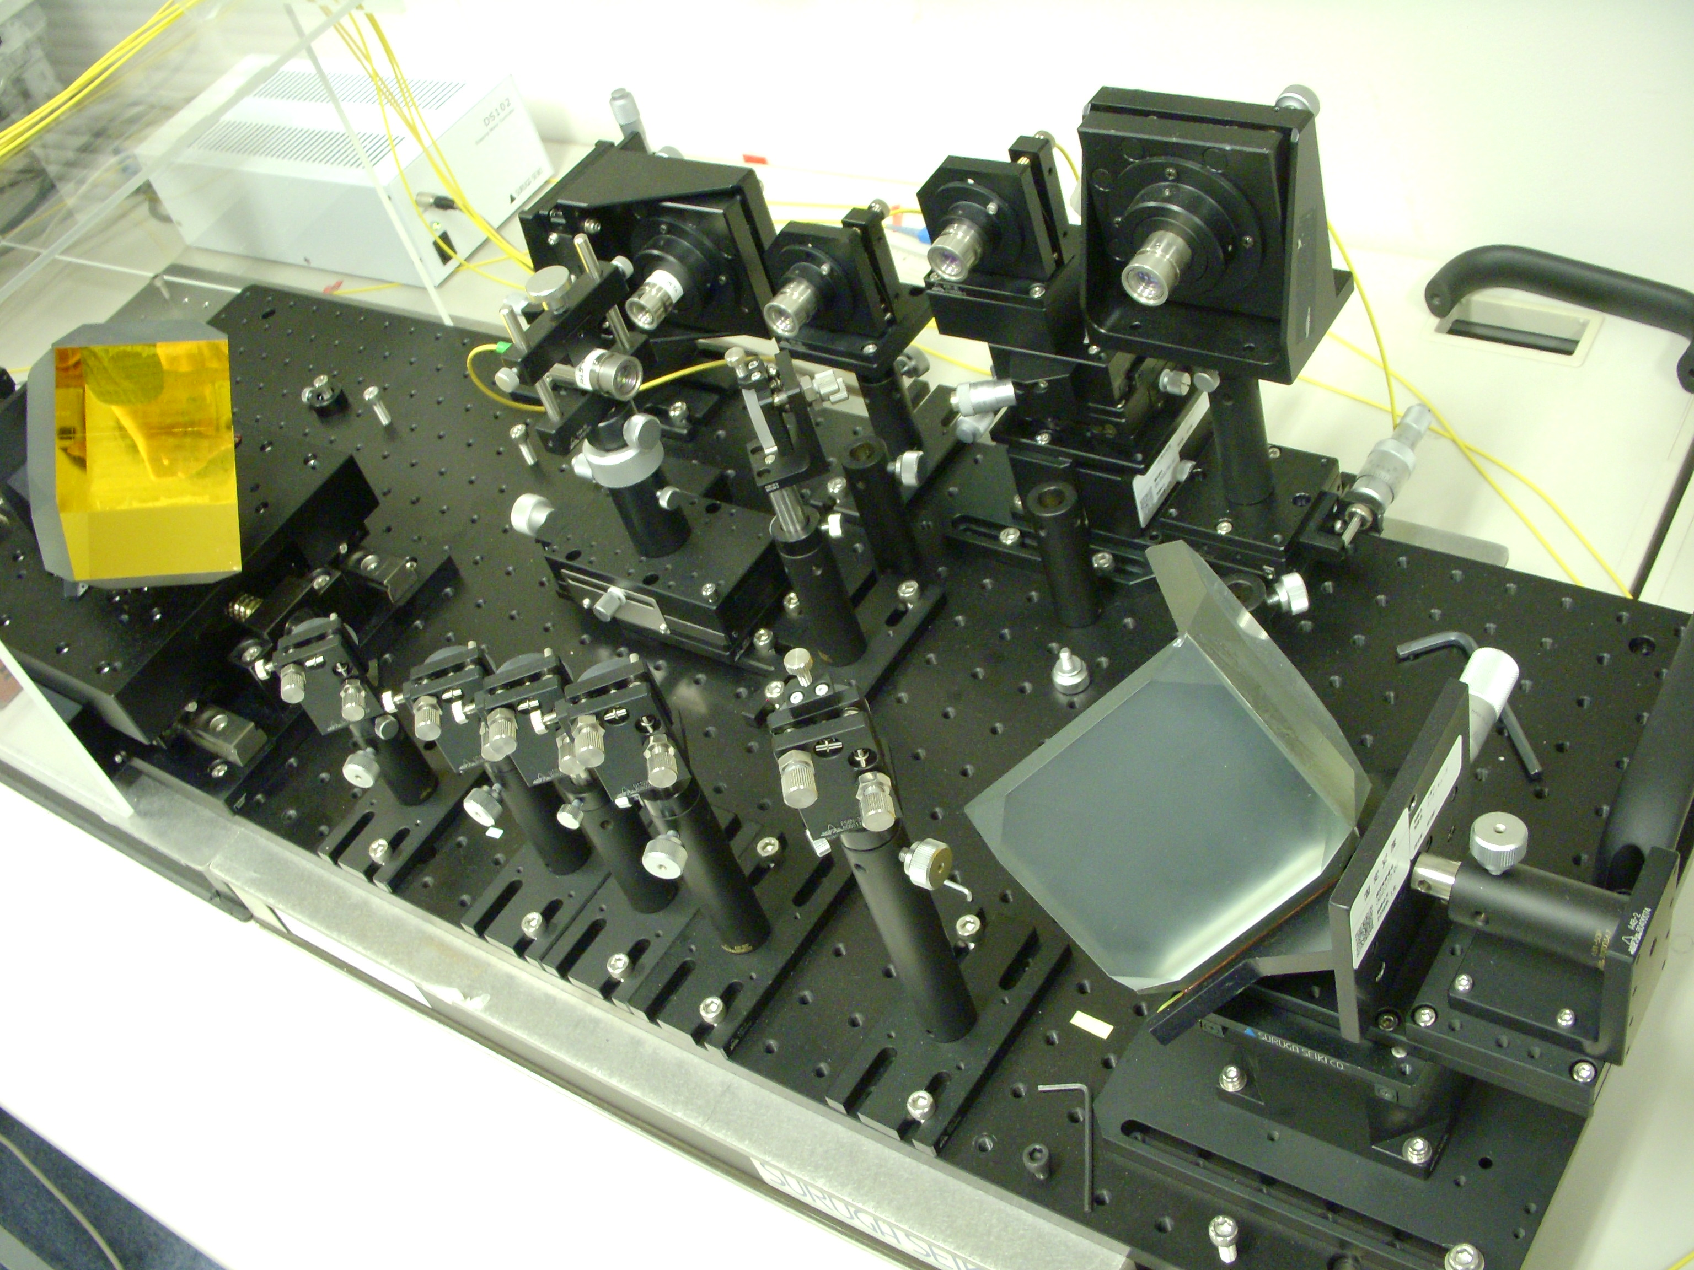

Photo 1 Free-space optics line length adjuster.

Fig.6 Free-space optics line length adjuster.

The limit of the adjustable range is a practical problem when this system is applied to several kilometers of access network. Therefore, we employ optical line length accumulators. The optical line length adjuster contains two optical paths, #0 and #1 as shown in Fig. 1. An optical switch and an optical fiber selector are installed in each path. Optical switches control the optical pulse flow. Each optical fiber selector is equipped with various lengths of optical fiber, for example L₀, 2L₀ and 3L₀. The path length can be discretely changed by choosing any one of them.
The optical line length adjuster can extend the detour line as much as required using the following operation. First, the FSO system lengthens path #0 by L₀ by gradually increasing the retroreflector interval. After the optical fiber selector has selected an optical fiber of length L₀, the active line is switched from path #0 to path #1. The FSO system then returns to the origin, and the optical fiber selector selects an optical fiber of length L₀ instead to keep the length of path #0 at L₀. The FSO system increases the retroreflector interval again to repeat the same operation. In this way the adjuster accumulates spans extended by the FSO system. The scanning time of our prototype is 10 seconds, because the retroreflector operates at 30 mm/s.
The optical line length adjuster enables us to lengthen/shorten the detour line while continuing to transmit optical signals.

The optical line replacement procedure, shown in Fig. 7 where the transmission lines are simplified, is as follows:
- A detour line is established between a WIC and a 2x8 optical splitter.
- The detour line length is measured with a 1650 nm test light using an optical line length measuring technique, and is adjusted to the same length as the regular line using an optical line length adjusting technique. These techniques are described in the preceding sections.
- Once the lengths of the two lines coincide, the transmission signals are also launched into the detour line.
- The regular line is cut and replaced with a new line, while the signals are being transmitted through the detour line. A long-wavelength pass filter (LWPF) is temporarily installed in the new line.
- The test light measures the lengths of the new line and the detour line. The detour line is adjusted to the new line while communications are maintained. The LWPF prevents only the optical transmission pulses from traveling through the new line.
- The LWPF is then removed and the transmission is duplicated. The detour line is finally cut off.

Fig.7 Optical line replacement procedure.

We investigated the tolerance of the multiplexed signal synchronicity in advance. The transmission quality is observed by changing the difference between the duplicated line lengths. The results show that the transmission linkage is maintained if the difference is within 80 mm as with GE-PON. A multiplexed signal cannot be perceived as a single bit when the duplicated line lengths have a larger gap for 1 Gbit/s transmission. Because these characteristics depend on the periodic length of a transmission bit, the requirement is assumed to be severe when the method is applied to higher-speed communication services.
Next, we constructed a prototype of the optical line shunt system shown in Fig. 1, and applied it to a 15 km GE-PON optical transmission line replacement. A 10 m optical fiber extension was added to the transmission line, while optical signals were switched between the duplicated lines during transmission.
Figure 8 shows the frame loss that occurred during optical line replacement, which we measured with a SmartBit network performance analyzer. No frame loss was observed at any switching stage if the difference between the duplicated line lengths was less than 80 mm. If the difference exceeded 80 mm, signal multiplexing caused frame loss in stages (a) and (d). We confirmed that the optical signals can be completely switched between the regular, detour, and new lines on condition that the line length is adjusted with sufficient accuracy.
The experimental results proved that our proposed system successfully relocated an in-service broadband network without any service interruption.

Fig.8 Frame loss while replacing transmission line according to the procedure;
(a) Multiplex signals of current line and detour line,
(b) Cut current line, (c) Extend detour line,
(d) Multiplex signals of detour line and new line,
(e) Cut off detour line.

5. CONCLUSION

We proposed a new switching method for in-service optical transmission lines that transfers live optical signals. The method exchanges optical fibers instead of using electric apparatus to control transmission speed. The optical line shunt system is designed to apply to duplicated optical lines. An optical line length adjuster, designed based on an FSO system, continuously lengthened the optical line up to 100 m with a resolution of 0.1 mm. An optical line length measurement technique successfully evaluated the difference in length between the duplicated lines from 100 m to 10 mm. An interferometry measurement distinguished the difference between line lengths to an accuracy of better than 10 mm by analyzing interfering waveforms created by chirped laser pulses. We applied this system to a 15 km GE-PON network and succeeded in replacing the communication lines without inducing any frame loss.

References

- K. Tanaka, M. Zaima, M. Tachikura and M. Nakamura: Downsized and enhanced optical fiber cable transfer splicing system, 51st IWCS (2002).
- Y. Azuma, K. Tanaka, K. Yoshida, K. Katayama, T. Tsujimura, and M. Shimizu: Basic investigation of new transfer method for optical access line, IEICE Technical Report Japan, OFT2008-52, 27/31 (2008).
- K. Tanaka, T. Tsujimura, K. Yoshida, K. Katayama, and Y. Azuma: Frame-loss-free Line Switching Method for In-service Optical Access Network using Interferometry Line Length Measurement, OFC2009, paper PDPD6 (2009).
- T. Tsujimura, K. Tanaka, K. Yoshida, K.Katayama, and Y. Azuma: Infallible Layer-one Protection Switching Technique for Optical Fiber Network, Proc. 14th European Conf. on Networks and Optical Communications/ 4th Conf. on Optical Cabling and Infrastructure (2009).
- R.A. Saunders, J.P. King and I. Hardcastle: Wideband chirp measurement technique for high bit rate sources, ELECTRONICS LETTERS, 30-16, 1336/1338 (1994).
- S.-C. Cao and J.C. Cartledge: Measurement-Based Method for Characterizing the Intensity and Phase Modulation Properties of SOA-MZI Wavelength Converters, IEEE PHOTONICS TECHNOLOGY LETTERS, 14-11, 1578/1580 (2002).
- Adrian J. Torregrosa et al.: Return-to-Zero Pulse Generators Using Overdriven Amplitude Modulators at One Fourth of the Data Rate, IEEE PHOTONICS TECHNOLOGY LETTERS, 19-22, 1837/1839 (2007).
- Y. Fukada, K-I. Suzuki, H. Nakamura, N. Yoshimoto, and M. Tsubokawa: First demonstration of fast automatic-gain-control (AGC) PDFA for amplifying burst-mode PON upstream signal, ECOC2008, paper WE.2.F.4 (2008).
- K. Yoshida, T. Tsujimura and T. Kurashima: Seamless transmission between single-mode optical fibers using free space optics system, SICE Annual Conference, 2219/2222 (2008).

Takeshi Tsujimura (Member)


He received the B.S. and M.S. and the Ph.D. degrees in precision mechanical engineering from Tokyo University, Japan, in 1981, 1983 and 1995 respectively. He received Young Engineer Award of the Japan Society of Mechanical Engineers in 1989, Finalist in the SICE Annual Conference International Award in 2005, and Best Paper Award of SICE-ICCAS in 2006. He is a senior research engineer of Access Network Service Systems Laboratories, Nippon Telegraph and Telephone Corporation, Japan. He also serves as a professor of University of Tsukuba, Japan. He has been engaged in researches in intelligent robot for maintenance and construction of telecommunication outside plants. He is now engaged in development of advanced telecommunication systems including Free Space Optics.

Koichi Yoshida (Member)


He received the B.S., M.S., and Ph.D. degrees from Kyushu University, Japan, in 1987, 1989, and 1995, respectively. In 1989, he joined Nippon Telegraph and Telephone Corporation, where he is currently studying the design and control of opto-mechatronic systems aimed at maintenance automation for optical fiber networks. He received Best Paper Award of SICE-ICCAS in 2006 regarding automated axis alignment technology for free space optics system.

Kuniaki Tanaka


He received the B.S. degree in physics from Kochi University, in 1987, and the M.S degree in high energy material science from Kyushu University, in 1989. He jointed Network System Development Center, Nippon Telegraph and Telephone Corporation, in 1990, where he has been engaged in the research and development of optical fiber measurement and surveillance technologies. Since 2007, he has been engaged in the research of optical line switching system at NTT Access Network Service Systems Laboratories.

Kazunori Katayama


He received the B.S., M.S. degrees in physics from Okayama University, Japan in 1995 and 1997, respectively. In 1997, he jointed Access Network Laboratories, Nippon Telegraph and Telephone Corporation, where he has been engaged in the research and development of area home network. Since 2007, he has been engaged in the research of intermediate session control server and optical line switching system at NTT Access Network Service Systems Laboratories. He is a member of the Institute of Electronics, Information and Communication Engineers (IEICE) of Japan.

Yuji Azuma


He received the B.E. degree in electrical engineering from Doshisha University, Japan, in 1984. He joined the Ibaraki Electrical Communication Laboratories of Nippon Telegraph and Telephone Public Corporation (now NTT) in 1984. He has researched the characteristics of high-density optical fiber cables, evaluated the reliability of optical devices, and developed optical fiber maintenance equipment. He is a Senior Research Engineer, Supervisor, NTT Access Network Service Systems Laboratories. He is a member of the Institute of Electronics, Information and Communication Engineers (IEICE) of Japan.

 NTT Access Network Service Systems Laboratories, Tsukuba, Ibaraki-ken, 305-0805, Japan (Received July 16,2009)

