Application of Virtual Simulation Environment to
Fluid Catalytic Cracking Unit Control

Haruo TAKATSU* Takashi NOZAKI, Kenji OKADA**

Abstract: This paper reports how to utilize a virtual simulation environment using a dynamic process simulator for the purpose of process operation and control system design in industrial production systems. It also aims for the integrated engineering environment including all process life cycle phases such as process design, engineering, implementation, and maintenance. Virtual simulation environment using rigorous model based dynamic simulator and multi-variable model predictive optimizing control covering large process unit has been developed and applied to the fluid catalytic cracking unit control. Effectiveness of the environment has been confirmed from the viewpoint of not only process engineering but also control engineering. Virtual simulation environment is also applicable to the evaluation of other operation and control systems.
Keywords: Advanced Process Control and Optimization, Dynamic Simulator, Fluid Catalytic Cracking Unit, Modeling and Simulation

I. INTRODUCTION
From the viewpoint of plant life cycle management, primary industries such as petroleum refineries and petrochemicals have been shifting from the age of high-growth production to the age of stable-growth production. In the high-growth production age the mass-production cycle makes it possible to realize cost reduction and improvement of production efficiency resulting in a new subsequent investment. On the other hand, in the stable-growth production age the flexible amount production cycle is required to respond to rapid market demand changes and to shorten the product cycle of plan, design, production and sale, resulting in the acquisition of customer expectations.
Furthermore, industrial societies have been facing with complex issues related to production activity. For example on the design of a production control system, not only key performance index but also environment-conscious measures such as complying with regulations addressing NOx and CO2 emissions, resource-saving and energy-saving operation issues et al. in all phases of production activities. The current industrial manufacturing and processing technologies is required to face with these issues described above.
On the other hand, Fig.1 shows recent production and control systems, which consists of several functionally autonomous sub-systems with the state-of-the-art technology. When the information exchange and the share of the obtained knowledge from information among these systems will proceed more through all the activities of plant design, control system implementation, plant operation and system maintenance phases in order to establish total engineering environment, we can simulate and experience various issues described above in advance and will find any solutions before control system implementation. Key issue is the interoperability on all the levels of hardware, software and application. On hardware and software levels, commercially available technologies such as Ethernet, Internet, OPC, XML exist. Application level connection needs any mathematic models of actual industrial plant and industrial control system. Furthermore recent simulation technology has enabled to supply a realistic dynamic simulator in place of the target plant for online use. And some control systems also have emulation functions which are transportable to personal computers or work stations in the commercial market.
Based on these backgrounds, we have developed the virtual simulation environment using rigorous model based dynamic simulator and multi-variable model predictive optimizing control, and have applied it to the fluid catalytic cracking (FCC) unit control for evaluation, aiming at the future flexible production systems. In section II and III, functional requirements of dynamic simulator and multi-variable predictive controller which are main sub-systems of the virtual environment, are explained. Section IV depicts the basic design of subsystems in the open operation environment. Section V describes the control target process: fluid catalytic cracking unit and the applied control scheme. In section VI the behavior of simulation process environment, stability evaluation of multi-variable optimizing control system and estimation of product quality using on-line software sensors have been evaluated. Optimal controllability to track the market demands, have been confirmed for future study. Finally the conclusion is listed up.
* Yokogawa Electric Corporation
2-9-32 Naka-cho, Musashino-shi, Tokyo, Japan
** Techno Systems Kyushu Corporation
26-30 Morishita-cho, Yahatanishi-ku, Kitakyushu-city,
Fukuoka, Japan
(Received July 7, 2003)
II. DYNAMIC SIMULATOR
Recent dynamic simulators, based on first-principle-based rigorous models, are required to be more accurate than steady state simulators to create optimal operation characteristics through online simulation [1]. Not only for operators training, control systems development and validation in process unit level, but also those in the plant wide level, satisfying the following functional requirements are necessary.

Model fidelity
The unit models constructed in dynamic simulators require the same or higher level of accuracy than those in steady-state simulators. For example, the vapor-liquid equilibrium and heat balance calculations are performed at each tray in the distillation tower, and the internal pressure caused by changes in the vapor hold-ups is calculated. Both functions are done in the same manner in the dynamic and steady-state simulators.

Scale of simulation
To examine training and operations in dynamic circumstances such as shutdown and startup, dynamic simulators require modeling of control equipments, pipelines, valves, and safety and auxiliary equipments. Therefore, they require 10 to 100 times more equipment items than steady-state simulators for the same type of plant.

Standard unit modules
Equipment items required in the dynamic simulator, such as tanks, safety valves, check valves, time lag pipes, measuring instruments and control equipment, are often required to function identically to the actual one because of its dynamic characteristics and different handling procedures in operations (e.g., pumps, compressors, valves of every kind, filters in the pipes and other small equipments). Therefore many different types of unit models must be prepared as standards in the dynamic simulator.

Execution functions
Dynamic simulators need high-performance computers to calculate large-scale simulators with rigorous models on a per-second basis. Fast-forwarding and playback functions are also effective for use.

Engineering environment
In simulator design, one plant is divided into several process models, and the engineers assigned in each division perform development tests independently. The process flow diagrams (PFD) of dynamic simulator require a more efficient operating environment with GUI due to the use of a substantial number of unit models.

Open Interface
In order to realize the virtual simulation environment, each component is required to have an open interface for mutual connection. For example, OPC interface including both client and server functions is used to communicate the current data among components. Definition information related to model is transformed using CSV or XML format. ActiveX component or Web interface is prepared to integrate human interface information for operators and engineers.
III. MULITI-VARIABLE PREDICTIVE CONTROL
Recently multi-variable model predictive control method (MPC) used in industrial process such as DMCplus, SMOC, and RMPCT, is recognized as one of the indispensable tools to improve and optimize their plant profitably [2]. From the control point of view, MPC computes the predicted value of the target process output, realizes the stable and effective control and produces the high quality products with minimum energy and costs. On the other hand each application of MPC requires the enough knowledge of the target plant and operation in order to tune embedded control models (identify input/output models) and control parameters more adequately. On the development of a new MPC, the accumulated operation results for many years in the field of petrochemicals, the implementation technologies of control systems and knowledge obtained using dynamic simulators should be combined to realize a true control system.
Furthermore, MPC should have the following features in order that the control algorithm can be smoothly introduced to process control systems and be applied to industries from the practical viewpoint for use.
Independence on Process Control System difference
MPC should be connected to any vendors’ DCS and PLC (recently called PCS). Data access interface is common to any PCS and be flexible to cope with difference of PCS functions. Interface should be standardized as universal stations.
Flexibility of system configuration
Flexible system configuration to implement customers’ requirements, connectivity to third parties software, and expandability during plant life cycle, these are taken into consideration in MPC development, which will increase the MPC operating ratio for use. Online configuration parameters change is effective to run MPC together with dynamic simulator in various operating condition.
Human Interface integration
In process control systems, variety of software packages are implemented to realize the total process control and operation. Integration of HMI of the software is required, especially to make it easier for operators to use. Active-X components, Web interface, DCS interface are prepared for the usage above.
Combination with other data processing software
MPC have a role of multi-variable control portion of total control system. But in order to realize the optimizing control, the combination of data pre-processing function such as inferred system or neural network, static optimizer, scheduling and so on are indispensable. Connection to other software package is also important described in the previous session.

IV. DESIGN AND IMPLEMENTATION
To run plural subsystems in collaboration with each other in open operation environment, the following design policy was considered and applied.
Real-time database structure and interface

Each subsystem has a real-time database which data is accessible from other subsystems. For example MPC controller has a flat database such as ‘main-controller name’ ->‘sub-controller’ -> ‘Input/output number’ -> ‘Item name’. On the other hand, each subsystem has also some interface to access other systems database. DCOM and OPC technologies are becoming common in this field. But in this case each subsystem should provide both OPC Server and OPC Client functions to communicate with each other.
Configuration database and interface

Subsystem should be configurable to be updated according to the operating condition changes. In order to cope with this, each subsystem has some local database for configuration information. But in order to exchange the information among subsystems and integrate all subsystems in the future, more mass and flexible methods are required. We have adopted XML technologies for these purposes. XML technology has now been the de facto standard for information exchange. Table 1 is a example in case of MPC. This definition is shared among the controller design tool, the online controller and Operator interface.

Table 1 Example of Configuration Data
<CONTROLLER_DEFINITION_FILE>
<GENERAL_INFO> | <CONTROLLER_TAGNAME VALUE = "stabilizer" />
 | <EXECUTION_TOLERANCE VALUE = "1.0" />
 | <REQUESTED_STATUS VALUE = "03SMOC01_SREQ.SW" />
 | <ACTUAL_STATUS VALUE = "03SMOC01_SACT.SW"/>
 | …………………………………..
</GENERAL_INFO>
<SUBCONTROLLER_DEFINITION> | <ALIAS>stabilizer</ALIAS>
 | …………………………………..
</SUBCONTROLLER_DEFINITION>
<MV_DEFINITION> | <ALIAS>03F586SV</ALIAS>
 | <MEASUREMENT VALUE = "03F586.PV" />
 | <SPREADBACK VALUE = "03F586.SV" />
 | <REMOTELOCAL VALUE = "03F586RL.PV" />
 | <OUTPUT VALUE = "03F586.RSV"/ >
 | …………………………………..
</MV_DEFINITION>
<CV_DEFINITION> | <ALIAS>03Q590POV</ALIAS>
 | <CALCULATEDVALUE VALUE = "SMOC01CVCAL.DT06" />
 | …………………………………..
</CV_DEFINITION>
</CONTROLLER_DEFINITION_FILE>
Monitoring and operation interface

In order to integrate the information of multiple subsystems into one PC or to migrate to multiple vendors’ environment, monitoring and operation interface should be implemented in independent of the server functions such as control and computation parts. Main parts of HMI should be implemented using de-fact standard software environment such as Visual Basic Visual C, MS-Excel and HTML. Each subsystem only provides interface specification, ActiveX components, dynamic link libraries or wrapper software for connection. Table 2 is an example of ActiveX components prepared for MPC.
Table 2 Example of ActiveX components
Name | Function
Trend | Display of historical data
Message | Real-time display of alarm occurred
Control Panel | Monitor and control of MPC
Overview Panel | Overview panel for operation
Manipulated Value Panel | Detail panel of manipulated panels
Control Variable Panel | Detail panel of controlled variables
ESV Panel | Detail panel of economical setpoints

V. FCC UNIT CONTROL
In order to confirm the effectiveness of the simulation environment like Fig.1, it was applied to a residue fluid catalytic cracking (FCC) unit.
FCC virtual plant
FCC unit selected as the control target process is shown in Fig.2 and Fig.3. Table 3 is the main specification of the FCC. The purpose of this process is to revamp the heavy crude oil into more valuable products such as gasoline, LGO, LPG. Fresh feed oil stream is warmed after passing several heat exchange units E301/E302 for energy saving, and its temperature is finally controlled by the furnace F301. The feed oil and the catalyst are sent to the reactor R301, where the feel oil is decomposed into more light products and be sent to the main fractionator C301. The deactivated catalyst which surface is covered by Carbon is transferred to the regenerator R302 and is burned with air. Catalyst is re-activated and Carbon is changed into CO (Carbon Dioxide) gas which is used as part of energy in the plant. The decomposed feed is sent to the main fractionator and distillated into several products such as gas oil, Naphtha, LCO, CSO using the boiling point difference. Parts of LCO is mixed with the fresh feed oil and re-circulated to the reactor and regenerator units.
The main factors which dominate the catalytic cracking are catalyst reaction temperature and reaction time. They depend on a balance of catalyst amount and temperature, feed oil flow and temperature. If reaction temperature is higher, the reaction makes progress more and many light components are produced. If the reaction time becomes longer, the cracking also progresses in the same way. On the other hand in order to control the reactor temperature, the controller reduces the amount of catalyst from the regenerator, which totally controls the amount of heat generated in the reactor unit.
Table 3 Process Operation Data
 | Operation Data | Specifications
Material to process | Atmospheric Residue (AR) | Specific Gravity 0.981  Sulfur Content (wt%) 3.46  Residual Carbon (wt%) 3.15  Metal Content (wt-ppm) 7.0
Production capacity | Atmospheric Residue (AR) | 200 kl/hour (30,000 BPSD)
Product | Naphtha | Octane value = 92.5, EP = 220°C
 | Light Circulated Oil (LCO) | ASTM90% = 365°C, Color = 3.5 ASTM, CFPP = -8.2°C
 | Slurry oil (CSO) | Viscosity (122F) = 2800C.St
FCC model has been implemented using the dynamic simulator described on Reference 1. As the dynamic simulator helps to build the rigorous model based simulator, it is effective to simulate the actual plant behavior including plant startup, shutdown, operation mode change for control evaluation.

Controller design
Two multi-variable model predictive controllers are applied on the FCC process. One controller is configured to control the reactor and the regenerator units, and another controller is to control the fractional operations of a distillation column. Table 4 and Table 5 show the configurations of controllers. Manipulated variables and control variables are described in Fig.2 marked as ‘MV’ and ‘CV’.

Table 4 Input/Output of Reactor & Regenerator Unit
 | Variables | Specifications
Controlled variable (CV) | Reactor temperature | Setpoint, High Limit
 | Upper Regenerator Bed Temp. | Setpoint, High Limit
 | Flue gas oxygen | Setpoint, Low Limit
 | Catalyst / Oil ratio | High Limit
 | Catalyst circulate rate | High Limit
 | Power recovery | Low Limit
 | Low Regenerator Temperature | High Limit
Manipulated variable (MV) | Feed flow rate | Setpoint
 | Slurry recycle to Reactor | Setpoint
 | Feed Temperature | Setpoint
 | Reactor Temperature
 | Regenerator Air Flow
 | Lancer air to Cooler

Table 5 Input/output of Main Fractionator Unit Control
 | Variables | Specifications
Controlled variable (CV) | Feed flow rate | Setpoint, High/Low Limits
 | Slurry recycle to Reactor | High Limit
 | Feed Temperature | Setpoint, High/Low Limits
 | Reactor Temperature | Setpoint
Manipulated variable (MV) | Auxiliary reflux flow
 | LCO product flow rate
 | LCO Pump Around Return Temperature
 | HCO Pump Around Return Temperature
The main control purpose of reactor and regenerator units is to stabilize the catalytic cracking reaction not only the steady state condition but also the transition state condition from one operation point to another. As operational constraints, the regenerator column (top-stage and bottom-stage catalyst layer temperatures), reactor column (riser temperature), catalyst circulation amount (amount of catalyst passing through a reactor-column slide valve), and the catalyst/oil ratio are to be maintained within fixed ranges. Moreover, the concentration of oxygen in exhaust gases is specified to be 2% or more to prevent improper combustion-caused catalyst regeneration failure or environmental contamination.
In the main fractionator control, the product quality of Naphtha and LCO will be stabilized to increase more the yield of high-value added products. Due to the process characteristics limitation, NAP EP, LCO CFPP, and ASTM90% cannot be controlled to arbitrary values simultaneously. Therefore, the control priority is given in the order of EP setpoint of Naphtha, ASTM90% setpoint of LCO, CFPP setpoint of LCO, and column-top temperature setpoint.

Control model
Fig.4 depicts the control model of the reactor and regenerator controllers. Vertical line corresponds to process input variable (MV) and horizontal line is process output (CV). The model can be described in the form of the transfer function of first and second order process with delay, which makes operators to understand easier. Model is designed by the identification and modeling tool, using the applied test signals data and the subsequent process output data in the simulator. As the relationship among the catalyst rate, the difference of reactor temperature and regenerator temperature and required heat amount for reaction, is nonlinear, the application of linear model is seems to be restricted but it is evaluated at the next step. .
VI. EVALUATION

The simulation system has been evaluated from the following operation and control point of view.

Process behavior
Dynamic simulator can simulate the detail behavior of each component in the process stream. Fig.5 shows the each stream’s component properties of the main fractionator on the transaction towards the optimal operating point. Each graph in Fig.5 is corresponding to FI315 gas flow rate, FC312 Naphtha flow rate, FC203 LCO flow rate and FC310 CSO flow rate. According to the progress, GAS (CH4,C2H6,C3H8,C4H10) & Naphtha (NBP44, NBP88, NBP118, NBP149, NBP180) components are increasing. As CSO is partly recycled to the reactor session together with refresh feed, there exists lower limit constraint for operation as is shown in the graph. As the dynamic simulator can mimic the chemical components on each stream, it is possible to use the simulator for controller evaluation, operation assistance and so on.

Multi-variable control
Fig.6 and Fig.7 are the control test results to confirm the process behavior. In Fig.6 the feed flow rate FC301 has changed with 3 m3/h at first. Then the controller manipulated the feed temperature TC303 to keep the Catalyst/Oil ratio DR330 constant and also manipulated the regenerator air flow FC335 to keep stable the O2 density AI330 in the exhausted gas. As the air flow change affects the regenerator upper temperature TI332, the catalyst cooler air flow FC336 has also manipulated. During these operations, the reactor temperature TC330 has been still kept stable.
As is shown in Fig.7, the operation mode has changed to maximize the upper temperature of regenerator TI332. As the result, the catalyst temperature up, the decrease of catalyst flow, the feed temperature down, and the decrease of catalyst cooler air flow have occurred. During this operation the reactor temperature TC330, flue O2 density, and catalyst to oil ratio have been kept stable. Feed temperature has decreased due to the catalyst temperature up and the second effect of constant catalyst to oil ratio.
Finally the recycle flow FC309 has increased at 240 minutes point. We can also confirm TI332, TC330, AI330A and DR330 are stable.

Property estimation
Using FCC virtual simulation environment, the components properties can be estimated with enough estimation accuracy. To confirm this, the comparison was performed. The analyzer model was implemented in the simulator and the software sensor was also applied as the input of multi-variable controllers. Fig.8 depicts the comparison result. The graphs show the trend of Naphtha end point and LCO CFPP (cold filter plugging point). The simulation condition is the same as the operation mode change previously described. The black (dark) line shows the output of the simulator which represents the actual component property. Green (thin) line is the estimated value which is calculated using the embedded software sensor. Red line (dotted data) shows the output of the analyzer which is implemented in the simulation environment. There does not exist so much deviation between the actual property and estimated output as the comparison with the analyzer output.
In order to get enough estimation accuracy of software sensor, selection of input data, stabilization of local control loop, periodical bias estimation, adaptation of low pass filter are applied. Software sensor design tool is also available to support these works. As the result we can get enough estimation using software sensor even when the operation mode has changed.

Optimization
Prior to connecting the optimizer online, the optimum points were calculated offline to verify the controllability during the transition among optimum operation points. Here are made optimization calculation of the reactor column using two objective functions of LCOmax (maximize the light cycle oil profit) and NAPmax (maximize the naphtha profit). The catalyst regenerator column and distillation column are out of optimization calculation scope. Objective functions are determined as polynomials of gas yield, naphtha yield, LCO yield, and CSO yield. These are values essentially related to money but values are normalized due to confidential reason. Two optimum points corresponding to LCOmax and NAPmax respectively were calculated in advance using the reactor-column static simulator to determine the optimum operation conditions (raw oil temperature, catalyst temperature, catalyst flow rate, and reaction temperature). To compare two optimized conditions of LCOmax and NAPmax, ESV was changed as ramp from the prior-to-optimized condition to LCOmax at first. After waiting until the FCC process became stabilized at LCOmax and then the process shifted to steady state, ESV was changed from the steady state to NAPmax. During the these transition the process behavior was confirmed if it was corresponding to the actual process behavior. The process was continuously stable and the controlled variables were kept these setpoints. Two objective functions were also computed during the transition to confirm the validity of the optimizer settings. The use of multi-variable prediction control and soft sensors allowed the transition between the calculated optimized points to be carried out quickly and smoothly. (Fig.9 & Fig.10)
VII. CONCLUSION
The conclusion is as follows.
- The virtual simulation environment combined the dynamic simulator with multi-variable control systems has been built.
- The effectiveness of virtual simulation environment was evaluated by applying it to FCC unit control.
- Effectiveness of model predictive control was confirmed using this simulation environment.
- Component estimation by software sensor was applied and the effectiveness was confirmed.
- The control performance on the optimization mode was confirmed via operation transition.
As the next step, using the virtual simulator environment, online plant optimization, safety analysis engineering like HAZOP and so on are also planned to be evaluated.
ACKNOWLEGE
This activity belongs to the international Intelligent Manufacturing Systems (IMS) Projects and was financially supported by IMS Center and New Energy and Industrial Technology Development Organization (NEDO) in Japan.

REFERENCES
1) Miura and Yokoyama: OmegaLand development concept and the function outline, Yokogawa Technical Reports, 45-1, 63/66 (2001). (Japanese)
2) Takatsu, Terashima, Okada: Multi-variable Optimising Control Exasmoc, Yokogawa Technical Reports, 45-3, 173/178 (2001). (Japanese)
3) Takatsu, Nozaki, Okada: Application of Virtual Simulation Environment to the Crude Distillation Unit Control, Proceeding of ISA Conference (2001)
4) Takatsu, Nozaki, Okada: Application of Virtual Simulation Environment to Oil Process Unit Control, Proceeding of SICE Annual Conference (2002)

BIOGRAPHES
HARUO TAKATSU received B.S. degree in control engineering in 1973 and M.S. degree in systems science engineering in 1984, respectively, from Tokyo Institute of Technology, Tokyo, Japan. He joined in Hokushin Electric Works Inc, (now named Yokogawa Electric Corporation) and has been working at System Business Division. His research interests include design and application of process control and optimization.

TAKASHI NOZAKI received B.S. degree in applied nuclear engineering in 1985 and M.S. degree in energy conversion engineering in 1987, respectively, from Kyushu University, Fukuoka, Japan. He joined in Asahi Chemical Corporation in 1987, changed his occupation to Techno Systems Kyushu in 1993 and he has been working at Advanced Operation Assist Section. His research interests include process simulation and process automation.

KENJI OKADA received B.S. degree in control engineering in 1997 and M.S. degree in control engineering in 1999, respectively, from Kyushu Institute of Technology, Fukuoka, Japan. He joined in Techno Systems Kyushu Corporation and has been working at Advanced Operation Assist Section. His research interests include engineering of process control.

Trademark: DMCplus is a trademark of Aspen Technology Inc. SMOC is a trademark of Shell Global Solutions Inc. RMPCT is a trademark of Honeywell International Inc. Ethernet is a trademark of XEROX Corporation. Microsoft, Windows, Visual Basic, ActiveX are trademarks of Microsoft Corporation. All other company and product names are registered trademarks or trademarks of respective companies.

Fig. 1 Virtual Simulation Environment
Fig. 2 Outline of Control over the Fluid Catalytic Cracking Unit
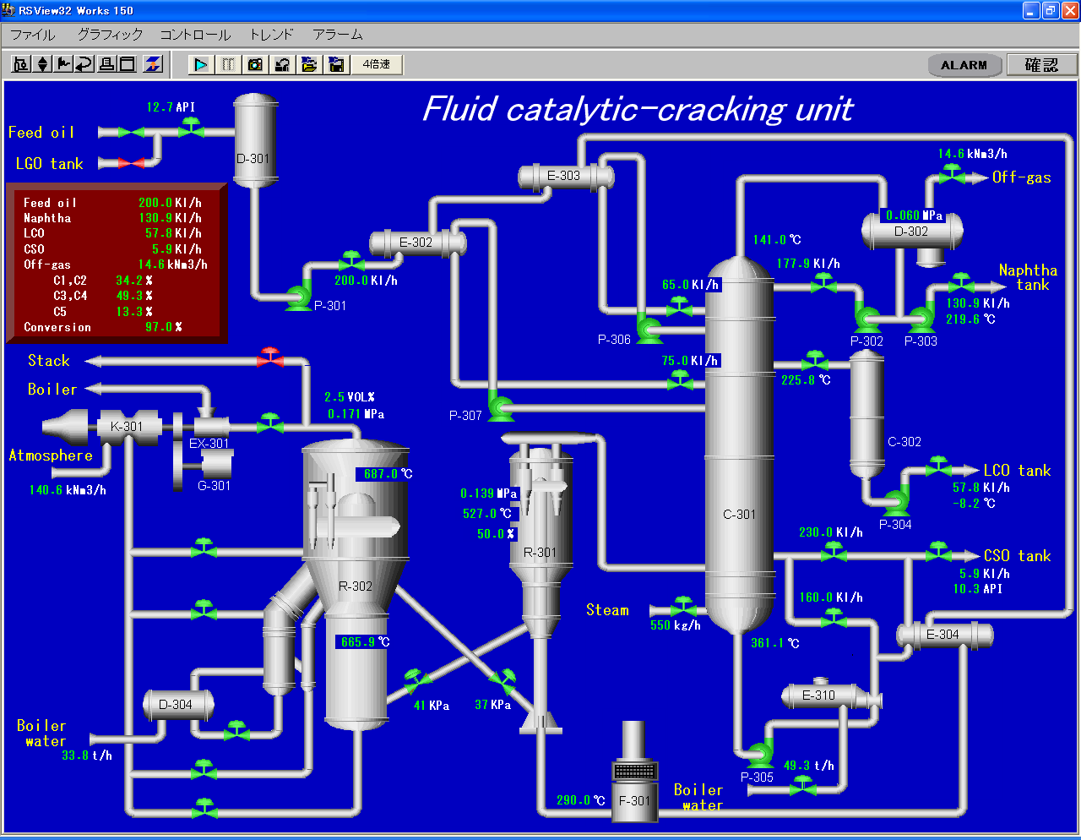

Fig. 3 Panel example of Dynamic Simulator

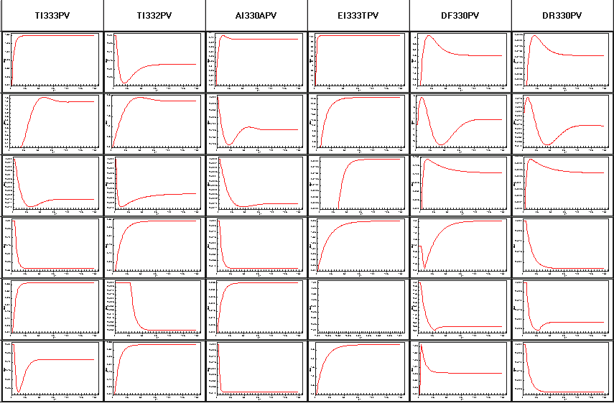
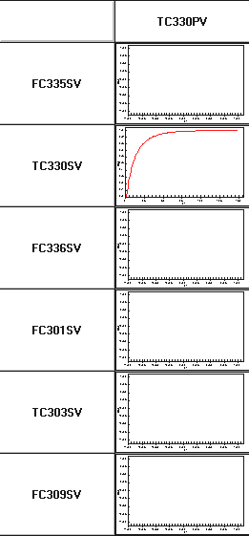

Fig. 4 Control Model of the Reactor and Regenerator Units

GAS FI315 components trend
NAPHTHA：FC312 components trend

LCO：FC302 components trend
CSO：FC310 components trend
Fig. 5 Componet streams in the main fractionator

Fig. 6 Control test of the Reactor and Regenerator Units (1/2)

Fig. 7 Control test of the Reactor and Regenerator Units (2/2)

Fig. 8 Property Estimation

Fig. 9 Transition of Optimization status

Reactor Temperature TC330
Regenerator Temperature TI332
Objective Function LCOmax
Objective Function NAPmax

Fig. 10 Transition of Optimization Control

