Development of a Support Tool for Constructing
an Analysis Model for a Stock Portfolio

Shinsuke TAKAHASHI＊and Makoto MIYATA＊

One problem with current portfolio management systems is that they cannot easily keep their analysis accuracy in regard to emerging markets (whose characteristics change frequently), because a model with fixed structure (i.e., fixed explanatory variables) is used and cannot keep up with changing market characteristics. To overcome this problem, the authors have developed a support tool for modifying and evaluating a model used for risk analysis. The tool can construct a model with arbitrary explanatory variables by using various types of regression analysis methods and model evaluation methods, and it can also keep the accuracy of the model constant over time.

Keywords: portfolio management, multi-factor model, support tool, emerging market, regression analysis
* Systems Development Laboratory, Hitach, Ltd.
292, Yoshida-cho, Totsuka-ku, Yokohana-shi 244-0817
(Received March 2, 2005)

1. INTRODUCTION
Stock portfolio of pension and investing funds are managed systematically in a series of processes consisting of investment-strategy planning, portfolio construction, risk analysis, and so on. And to make appropriate decisions during these processes, quantitative analysis of stock markets and stock portfolio is indispensable.
In Europe, America, and Japan, a multi-factor model has mainly been used for the quantitative analysis ⁽¹⁾⁽²⁾⁽³⁾. It is also called a risk model because it is used for risk analysis. The model is constructed based on least squares, cross-sectional, multiple regression analysis where an explained variable is stock return and explanatory variables are various factors that influence stock return. To construct an accurate multi-factor model, it is important to select appropriate factors (explanatory variables) that express stock return. Risk and performance analysis can then be performed by using this model.
In Japan, Aegis Portfolio Manager ⁽⁴⁾ of BARRA Inc., Portfolio Master ⁽⁵⁾ (developed by Nikkei Media Marketing, Inc.), and Risk Scope ⁽⁶⁾ of Hitachi Ltd. are well-known portfolio management systems that use the above-mentioned risk model. All explanatory variables of the risk model are fixed. In mature Japanese and American markets, the accuracy of the model will not drop in the near future. On the other hand, in an emerging market like China whose characteristics are thought to change frequently, the problem of “model staleness” will arise; accordingly, the accuracy of analysis will drop because the model has fixed structure (i.e., fixed explanatory variables) and thus it can not continue to follow the changing market characteristics. Market characteristic will change when new financial data like forecast are issued or regulations on stock exchanges change. Accordingly new explanatory variables must be added to the model to keep accuracy of analysis.
To use the model in such a changing market, it is necessary that users can modify and evaluate it.

Accordingly, the authors have developed a new tool –called a risk model builder- that allows users to construct and modify the model for risk analysis. Using this tool, a user can build a risk model with arbitrary explanatory variables comparatively easily by means of a previously determined procedure. Key features of this tool are as follows.
1) New factors (new explanatory variables) can be defined flexibly by combining 35 previously selected descriptors. (Note: a descriptor is a basic indicator that influences stock return.)
2) Various regression methods can be used to make an accurate model.
3) The constructed model can be adjusted using historical data.
4) The model constructed by using the regression results can be registered in the new tool, and risk and performance of a sample portfolio can be analyzed by using the registered model.
2. STOCK PORTFOLIO MANAGEMENT AND RISK MODEL
2.1 Stock Portfolio Management Process
A typical portfolio management process used by fund managers is shown in Fig. 1. The main steps of this process are explained as follows.
● PLAN
First, beta (market timing) and factor-tilt strategies are planned, and then appropriate level of active risk is planned. Beta is the sensitivity of a stock portfolio to a benchmark portfolio. A high beta portfolio generally has high risk and high-expected return; a low beta portfolio has low risk and low-expected return. The aim of a beta strategy is to determine an appropriate beta for a portfolio by using market analysis.
The aim of a factor tilt strategy is to determine what factor the stock portfolio should be tilted toward from among the various factors that influence stock return. Examples of factors are profit-to-market cap ratio, sales-to-market cap ratio, asset and trading turnover. More details on these factors is given in Section 3.3.
Active risk is the standard deviation of active return (which is the subtraction of portfolio return and benchmark return). It is determined by the acceptable risk level of a fund or a pension.
● DO
A new portfolio is constructed or a portfolio is rebalanced according to planned strategies.
● SEE
Whether the portfolio has achieved its expected performance and whether the risk level does not deviate from the target level are evaluated. Based on this evaluation, investment strategies are re-planned in the “PLAN”. The cycle of this series of processes is about one month, although it varies for each fund.
A stock risk model helps fund managers to plan beta and factor-tilt strategies in the PLAN process, and to evaluate risk and performance of a stock portfolio in the SEE process.

Fig. 1 Portfolio-management process

2.2 Stock Risk Model
A mathematical model for analyzing the risk of stock portfolio is explained in this section.
(1) Multi-factor model
A linear model (called a multi-factor model) is generally used to analyze risk and performance of a stock portfolio. The numerical expression of this model is given as follows.
$r=X⋅f+e$ , $X=[X_{0},D]$ ……………..(1)
$r=[r_{1} r_{2} \text{.}\text{.}\text{.}\text{.}\text{.} r_{n}]^{T}$, $f=[f_{1} f_{2} \text{.}\text{.}\text{.}\text{.}\text{.}\text{.} f_{k}]^{T}$,
$e=[e_{1} e_{2} \text{.}\text{.}\text{.}\text{.}\text{.} e_{n}]^{T}$,
$X_{0}=\begin{aligned}\left[x_{\text{11}} x_{\text{12}} \text{.}\text{.}\text{.}\text{.}\text{.}\text{.}\text{.}\text{.}\text{.}x_{1l} | \right]\left[x_{\text{21}} x_{\text{22}} \text{.}\text{.}\text{.}\text{.}\text{.}\text{.}\text{.}\text{.}\text{.}x_{2l} | \right]\left[ | \right] \\ \end{aligned}$, $D=\begin{aligned}\left[d_{\text{11}} d_{\text{12}} \text{.}\text{.}\text{.}\text{.}\text{.}\text{.}\text{.}\text{.}\text{.}d_{1m} | \right]\left[d_{\text{21}} d_{\text{22}} \text{.}\text{.}\text{.}\text{.}\text{.}\text{.}\text{.}\text{.}\text{.}d_{2m} | \right]\left[ | \right] \\ \end{aligned}$
Component di,j is 0 or 1 and $\sum_{j=1}^{m}{d_{\text{ij}}=1}$, k=l+m
Here, r is monthly stock return vector on time (t+1), (Component rj is return to stock j); f is a regression coefficient vector (Component fi is also called factor return to factor i. The number of factors is k in this case, where, a factor is a kind of indicator that affects stock return and corresponds to an explanatory variable in a regression equation. More detail on factors is given in section 3.3.); X₀ is exposure (firm characteristics such as size, measures of profitability, etc.) matrix with time t (Component xi,j is the exposure to factor i for stock j.); D is a matrix for expressing interception in regression equation; and e is a residual term vector, i.e., unexplained component of return. (also called specific return). Generally an interception for the industry that each stock belongs to is provided
Time lag between return and exposure in expression (1) is given in order to predict future values of portfolio risk and so on.
(2) Estimation of factor return f
If data of matrix X₀, D and vector r are given, factor return vector f in expression (1) can be estimated using least squares, cross-sectional, multiple regression analysis. At the same time, specific return vector e can also be obtained. If time-series data of factor return and specific return are obtained by executing regression analysis over past time, stock portfolio risk can be estimated and portfolio performance can be analyzed by using that data.
(3) Formula for performance analysis
Various returns are calculated using the following formulas.
$R_{P}=h_{P}^{T}⋅r=h_{P}^{T}⋅X⋅f+h_{P}^{T}⋅e$ ……………(2)
$R_{M}=h_{M}^{T}⋅r=h_{M}^{T}⋅X⋅f+h_{M}^{T}⋅e$ ……………(3)
$R_{P}=β_{p}⋅R_{M}+R_{\text{res}}$ ……………(4)
$\begin{aligned}R_{\text{AR}}=R_{P}−R_{M} \\ =(β_{p}−1)⋅R_{M}+R_{\text{res}} \\ =(β_{p}−1)⋅R_{M}+(h_{P}−β_{P}⋅h_{m})^{T}⋅X⋅f+(h_{P}−β_{P}⋅h_{m})^{T}⋅e\end{aligned}$
……………(5)
$R_{\text{AR}}=(h_{P}−h_{m})^{T}⋅X⋅f+(h_{P}−h_{m})^{T}⋅e$ ……………(6)
Here, R_{P} is monthly portfolio return, R_{M} is monthly benchmark return, R_{AR} is monthly active return, R_{res} is monthly residual return, h_{P} is portfolio weight vector, h_{M} is benchmark weight vector, and β_{p} is portfolio beta.
In the case of actual stock management, active return is the most important indicator for measuring performance of investments. In formula (5), active return is decomposed into two terms, that is, systematic return (β_{p}-1)R_{M} influenced by value of portfolio’s beta and residual return R_{res}. Moreover, in formula (5), residual return is decomposed into two terms, that is, residual common factor return and residual specific return. From the calculation result by formula (5), the terms that contribute to active return can be determined. If systematic return is positive, it turns out that planning of beta was good. If residual return was positive, it turns out that selection of stocks was good. Cumulative returns can be calculated using time-series data for each monthly return such as monthly portfolio return, monthly active return, and monthly systematic return.
Also by means of the decomposition of the first term on the right side of formulae (2) and (6), the contribution of each factor to portfolio return or active return can be calculated.
(4) Formula for risk estimation
Total risk of portfolio and benchmark, and active risk are respectively calculated as standard deviation of portfolio and benchmark returns, and active return as follows.
$σ_{P}^{2}=h_{P}^{T}⋅X⋅\text{Var}[f]⋅X^{T}⋅h_{P}+h_{P}^{T}⋅\text{Var}[e]⋅h_{P}$ ……...(7)
$σ_{M}^{2}=h_{M}^{T}⋅X⋅\text{Var}[f]⋅X^{T}⋅h_{M}+h_{M}^{T}⋅\text{Var}[e]⋅h_{M}$ …..….(8)
$\begin{aligned}σ_{\text{AR}}^{2}=(β_{p}−1)^{2}⋅σ_{M}^{2} \\ +(h_{P}−β_{p}⋅h_{M})^{T}⋅X⋅\text{Var}[f]⋅X^{T}⋅(h_{P}−β_{p}⋅h_{M}) \\ +(h_{P}−β_{p}⋅h_{M})^{T}⋅\text{Var}[e]⋅(h_{P}−β_{p}⋅h_{M})\end{aligned}$….(9)
Here, σ_{P} is monthly portfolio risk, σ_{M} is monthly benchmark risk, and σ_{AR} is monthly active risk or tracking error.
In formula (9), active return is decomposed into three terms. The first, second, and third terms are respectively called active systematic risk, residual common factor risk and residual specific risk. From formula (9), the term that determines active risk can be found. Covariance matrix Var[f] and Var[e] of factor return and specific return are calculated according to their historical data.
(5) Procedure for building risk model
(a) Select and define factors used in the risk model
(b) Calculate factor exposure
(c) Calculate factor return and specific return using regression analysis and evaluate the calculation results
(d) Calculate covariance matrix Var[f], Var[e]
(e) Analyze risk and performance of sample portfolio and evaluate analysis results
If factor return calculated in step (c) does not precisely express market characteristics or if portfolio risk estimated in step (e) does not have satisfactory accuracy, return to previous step. If step (e) gives satisfactory results, finish the procedure. The built model (formulas (2)-(9))is the risk model.
3. OUTLINE OF RISK MODEL BUILDER
3.1 Outline and Feature of Builder
The risk model builder is a tool that helps users build their own risk model. The builder can build and evaluate a risk model with arbitrary factors. The built model can then be used to analyze risk and performance of a stock portfolio.
To build a model that can precisely analyze risk and performance of a stock portfolio, the following requirements must be satisfied.
●Adopt factors that can precisely express market characteristics
●Build an accurate model based on an optimal least squares method
●Adjust the built model according to historical data
●Introduce a method for evaluating the built model
The risk model builder possesses the following important features to satisfy the above requirements.
●Users can define a new factor by flexibly aggregating the 35 previously defined descriptors.
●Users can employ various least squared methods such as OLS (Ordinary Least Squared method), WLS (Weighted Least Squared method), and GLS (Generalized Least Squared method). Also users can select industrial or regional interception in regression analysis.
●Users can adjust the constructed model using various levels of risk calculated according to GARCH (Generalized Auto Regressive Conditional Heteroscedasticity) and ARCH (Auto Regressive Conditional Heteroscedasticity) models ⁽¹⁰⁾ and historical data of benchmark index.
●Users can evaluate model accuracy comparatively easily by comparing the actual return of a sample portfolio with estimated risk.
3.2 System Configuration and Function Outline
The system configuration of the builder is shown in Fig. 2. The builder is software that runs on MS Windows. It reads stock-return data and descriptors data form market and model DB database and stores factor exposure, covariance matrix, specific risk, and factor return in a model DB database through various calculation procedures.
The builder consists of the following four sub-tools
(1) Factor-exposure calculation
(2) Regression analysis
(3) Model test
(4) Data upload
Risk model can be constructed by using these tools in order. Constructing this model corresponds to executing the procedures in section 2.2 (5). The features mentioned in Section 3.1 are incorporated into these four sub-tools.
Risk and performance analysis system (Fig. 2) analyzes the risk and performance of a stock portfolio by using the constructed risk model (model DB Data). Model test tool also has similar analysis function.

Fig. 2 Configuration of risk model builder

3.3 Descriptor and factor
As shown in Table 1, we prepared 35 descriptors for the Chinese market. The factors can be defined by combining different ones. A standard risk model with eight factors was prepared for the Chinese market. The factors were defined by aggregating descriptors with similar characteristics (as shown in Table 1). Users can perform risk and performance analysis by simply using this model, although they can define their favorite factors and build an arbitrary risk model. In Table 1, the factors “Beta,” “Value,” “Liquidity,” “Technical,” “Volatility,” “Leverage,” and “Growth” respectively show sensitivity of each stock to a market, relative value based on sales and profit, level of liquidity for each stock, relative value based on technical indicators, level of volatility of each stock, level of debt and liability for each stock, and growth rate on each stock. As interception factors for the regression equation, 22 industrial factors and 35 regional factors are provided. A user can then select either industry or region when executing regression analysis.
The descriptor data in the model DB are constructed by another program. This program reads stock-price data, financial statement data and so on from the market DB, calculates descriptor data using the calculation methods shown in Table 1, and stores them

Table 1 List of descriptors and factors

in model DB. It is easy to define new descriptors and make data for them using this program.
4. DETAIL OF BUILDER
4.1 Main Window
The main window of the builder is shown in Fig. 3. If the user executes the builder program, this window will open. The upper four buttons are those for opening the four above-mentioned sub-tools. The fifth button is for opening a butch process function that can automatically execute procedures by the four sub-tools.

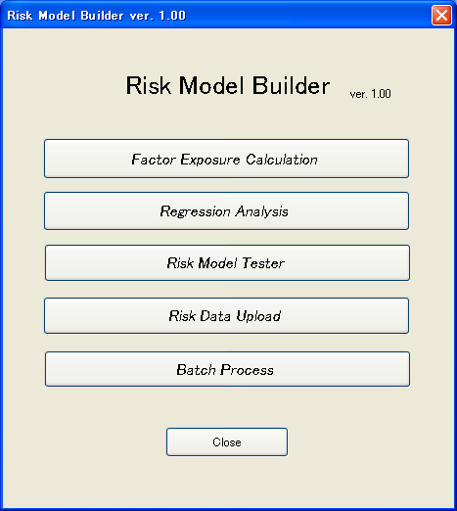
Fig. 3 Main window of builder

4.2 Factor Exposure Calculation Tool
(1) Calculation of factor exposure
Fig. 4 shows the main window of the exposure calculation tool. This tool is mainly for defining factors by a combination of prepared descriptors and for calculating exposure to the factors.
The factor exposure is calculated by weighted average of prepared descriptor exposures. For example, in Table 1, exposure to the factor “Beta” is given by average of exposures to descriptors “monthly beta” and “daily beta”. Here, not raw exposures but normalized exposures to the descriptors are used, and the obtained factor exposure is also normalized. The normalized factor exposure is finally used in the expression (1). The calculation of factor exposure includes this normalization process.
A formula used for the normalization is as follows.
$x_{i \text{new}}=\frac{x_{i \text{old}}−\bar{x}}{σ}$ ………………… (10)
When x_{inew}≧m₁, x_{inew}=m₁.
When x_{inew}≦-m₁, x_{inew}=-m₁.
When x_{inew}≧x_{med}+m₂・x_{mad}, x_{inew}=x_{med}+m₂・x_{mad}.
When x_{inew}≦x_{med}-m₂・x_{mad}, x_{inew}=x_{med}-m₂・x_{mad}.
Here, x_{inew} is a new exposure for stock i to one factor or one descriptor, x_{iold} is an old exposure or a raw exposure for stock i to one factor or one descriptor, $\bar{x}$ is an average or a weighted average of old exposures to one factor or one descriptor, σ is standard deviation of old exposures to one factor or one descriptor, m₁ and m₂ are positive constants that users designate and are usually set at values of 3 and 5, x_{med} is median of new exposures, and x_{mad} is median absolute deviation of new exposures.
The normalization based on expression (10) is usually repeated three times. This process is required to equally evaluate all factors whose level and range are different.
Next, the method for calculating factor exposure is explained about by referring to Fig. 4. A list of descriptors is indicated in the central window. Users can define and use a new factor by combining descriptors using the function shown in section 4.2 (4) or (5). If users designate descriptors and defined factors, input a calculation period into the upper edit box, designate a normalization method (explained in section 4.2 (2)), and push the “normalization button”, the normalization process is executed and the calculated exposure is stored in binary files in the tool.
(2) Designation of normalization method
If users push the edit button (i.e., second lowest), the window of Fig. 5 opens. In this window, users can designate whether Box-Cox transformation is performed or not before the normalization, the number of the normalization process, which weighting method for averaging exposure to use, equal weight or market cap weight, and the values of the constants m₁ and m₂.
Box-Cox transformation transforms non-normal distribution to normal distribution. Also if users utilize market cap weight, all exposures to the prepared eight factors for various benchmarks (such as the Shanghai A stock index and the Shanghai 180 stock index) can be set at a value of 0.0. Doing so enables the fund managers to plan and evaluate a factor-tilt strategy easily.
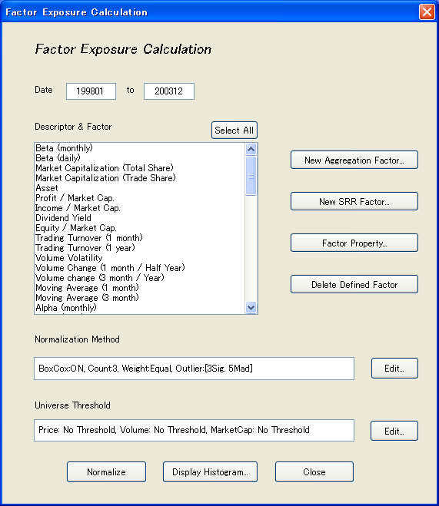
Fig. 4 Main window of exposure calculation tool

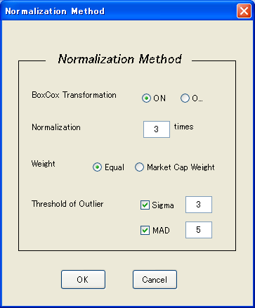
Fig.5 Window for designating normalization method
(3) Designation of universe
Using the lowest edit button in Fig. 4, users can restrict stocks used for calculating average of exposure in expression (10). Only stocks whose price, trading value, and market cap are respectively over designated values are used to calculate the average value.
(4) Definition of a new factor
If users push the “new factor aggregation button” in the main window, the window shown in Fig. 6 opens. If users input a new factor name, base descriptors, a weight for aggregation, and a method for dealing with missing data, and push the OK button, a new factor is defined and displayed in the central window in Fig. 4. Since exposure is not calculated by the definition, users must execute the normalization process.

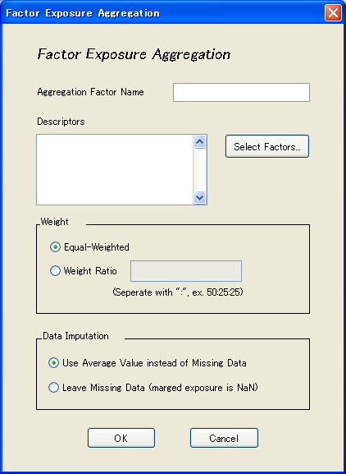
Fig. 6 Window for defining new factor

(5) Definition of SRR (Specific Return Reversal) factor
SRR factor is an indicator expressing relative value for each stock by SR (specific return) ⁽⁷⁾. Cumulative SR is used to calculate the exposure to SRR factor. For example, two-month cumulative SR for February 2002 is defined as the sum of the specific return for Feb 2002 and that for Jan 2002. The exposure to SRR factor is calculated by normalizing the cumulative specific return.
To obtain the specific return, the regression analysis must be executed. In Table 1, three factors (value, beta, and size) were used to calculate exposure to SRR factors.
The feature of this factor is that the smaller is the exposure to the SRR factor for one stock, the higher is the relative value of the stock. If “NEW SRR factor definition button” is pushed, the window shown in Fig. 7 opens. Then, if users input SRR factor name, a period for calculating the cumulative return, select general factors (as shown in Table 1) and interception factors (industry or region) for regression analysis, and push the OK button, a new SRR factor is defined. Since exposure is not calculated, the users must execute the normalization process.
(6) Display of exposure distribution
If users designate descriptors and factors on the central window of the tool and push the “Display Histogram button”, histograms of raw exposure and normalized exposure to the descriptor or the factor are displayed. Fig. 8 is an example display of a descriptor “monthly beta”. The number of normalization process was three and the Box-Cox transformation was used. The constants m₁ and m₂ were respectively set at values of 3 and 5. The calculated exposures were between -3 and +3, and a symmetric distribution of the exposures was achieved by the Box-Cox transformation. Such a distribution is needed to construct an accurate model for regression analysis in Section 4.3.

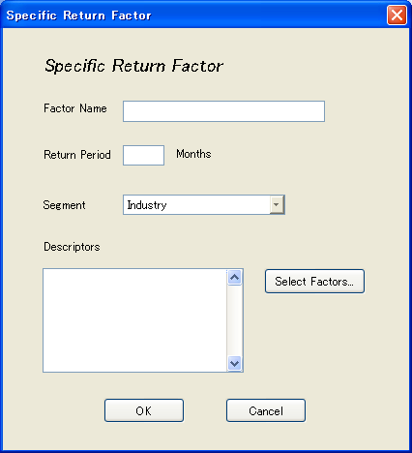
Fig. 7 Window for defining SRR Factor

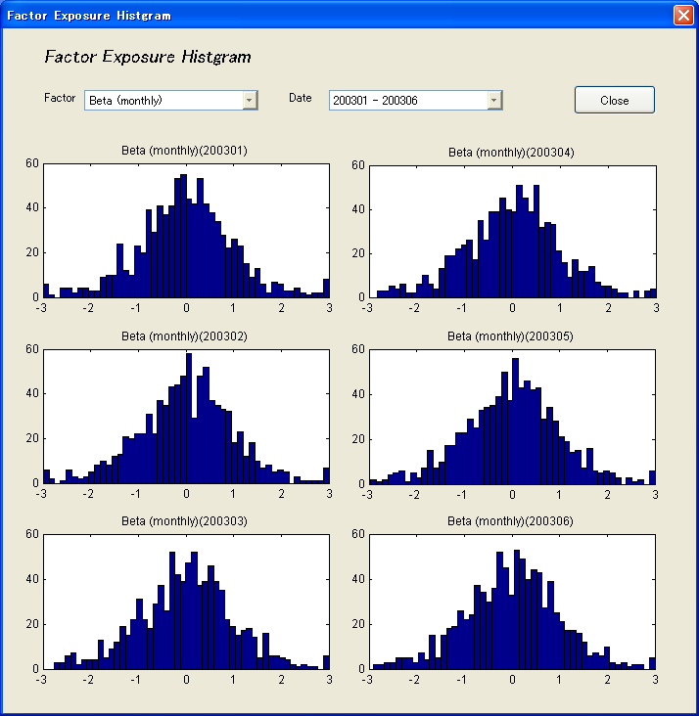
Fig. 8 Example of calculated exposure

4.3 Regression Analysis Tool
This tool is for executing regression analysis for expression (1). Stock return and calculated exposure are used for the regression analysis. The main window of the tool is shown in Fig. 9. If users select factors that compose explanatory variables, designate the regression method and the universe of stocks for the regression analysis, and push the “Regression button”, regression analysis is executed.
Fig. 10 is a window for designating the regression method. Users can designate multiple or single regression, OLS, GLS or WLS, and industrial or regional interception. GLS executes WLS method whose weight is an inverse of variance σ_{i}² of a specific return for each stock. The method can give an efficient estimator.
The following methods are considered for calculatingσ_{i}².
(a) Calculateσ_{i}² by using time-series data of specific return
(b) Calculateσ_{i}² by using Harvey’s model ⁽⁸⁾
A test using historical data showed that both methods can build the multi-factor model with the same accuracy because they got the similar t-stat. Finally, the first method was used in the regression analysis tool because the calculation of the variance is simpler.
WLS used market capitalization as a weight in regression analysis. A research ⁽¹⁾⁽⁶⁾ - namely, that an inverse of specific varianceσ_{i}² for each stock is almost proportional to a root of market capitalization or asset – is well-known. However, we used not the root of market capitalization, but market capitalization as weigth in WLS because the latter weigthing gave a better result.
In addition, 22 industrial factors and 32 regional factors are prepared as interception variables in expression (1). Users can restrict stocks used in regression analysis by the same method as used by the exposure calculation tool. In this tool, various statistics obtained by the regression analysis are also stored as CSV file. When multiple-regression only is executed, the “Display Results” button becomes valid. If this button is pushed, the window shown in Fig. 11 for displaying the analysis results opens.
Fig. 11 shows the result when eight factors in table 1 were defined and multiple-regression was performed. The upper left is a graph of cumulative factor return, upper right is a graph of period average of absolute value of t-stat. The lower left is a graph of the number of stocks (on Shanghai A and ShenZhen A stock markets) used in regression analysis and lower right is a graph of adjusted R-squared. The WLS and industrial factors are used for the regression analysis. According to the results, the t-stat of most factors was more than 2.0, and the mean value of adjusted R-squared was about 0.25 from January 2000 to December 2003. These results indicate that a good multi-factor model was obtained; namely, it can precisely express market characteristics.
Using this tool, users can also calculate correlation coefficient between any factors. If the “Correlation Analysis” button is pushed, correlation coefficients between selected factors are computed and the results are stored in CSV file. An example of calculation of correlation coefficients between the eight above-stated factors is shown in Fig. 12. It turned out that the correlations are low and there is no problem in term of multicollinearity. This function is useful for selecting a combination of factors with low correlation.
If good regression results are obtained, the risk model based on the results can be registered in this tool. If the “Save this model” button is pushed, the window shown in Fig. 13 opens. To employ this model in the model test tool described in the following section, users designate half life of an exponentially decreasing weight in order to calculate the covariance matrix of factors, and also the method for adjusting the estimated benchmark risk according to ARCH and GARCH models. If the OK button is pushed, the model is registered.
By pushing the “model load” button, users can access the model registered once and display the results.
4.4 Model Test Tool -
(Risk and Performance Analysis Tool)
This tool is for executing risk and performance analysis of sample portfolios using registered risk models. At the same time, users can evaluate the effectiveness of the model. Fig. 14 is the main window of the model test tool. In the window, registered models and previously prepared sample portfolios are displayed respectively in the upper and lower list boxes.
(1) Execution of risk and performance analysis
If users designate the risk model and sample portfolio in the window and push the “Risk Analysis” button, risk and performance analysis of sample portfolio is executed.
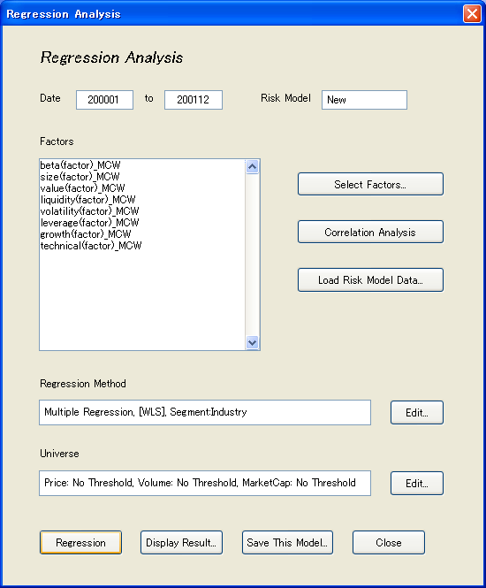
Fig. 9 Main window of regression analysis tool

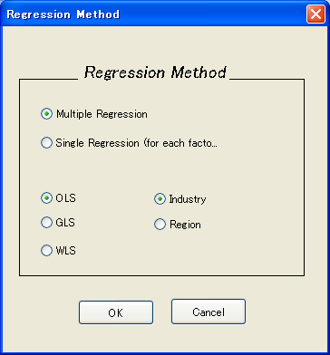
Fig. 10 Window for designating regression method

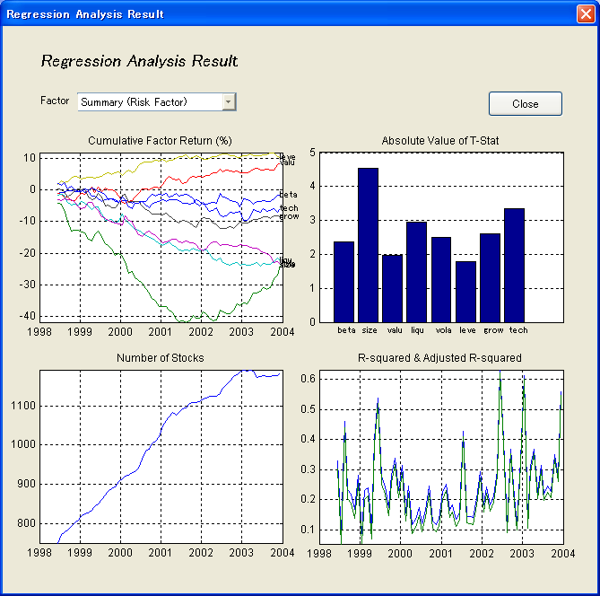
Fig. 11 GUI for displaying results of regression analysis
Fig. 12 Example of calculation of correlation coefficient
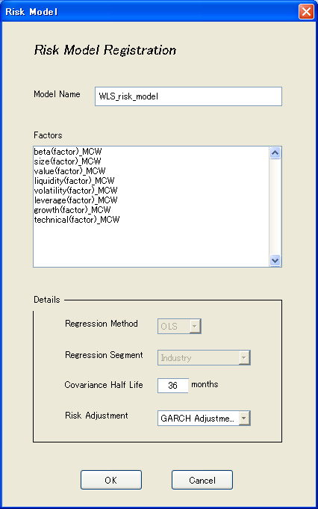
Fig. 13 Windows for registering risk model

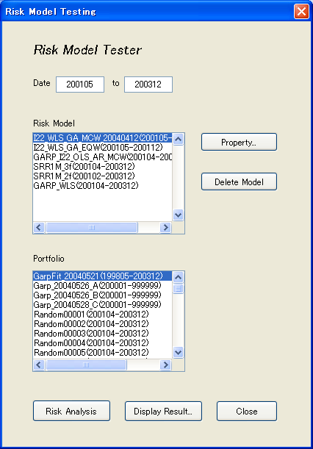
Fig. 14 Main window of model test tool

(2) Display of analysis results
If the “Display Result” button is pushed after the calculation is finished, an exclusive GUI opens. The GUI consists of three kinds of displays: (a) regression analysis results, (b) risk analysis results, and (c) performance analysis results.
(a) Display of regression analysis results
This display is for confirming the statistics obtained in regression analysis such as factor return and R-squared. The window is shown in Fig. 15. If “Regression Result” is selected on pull-down menu, this window is displayed.
(b) Display of risk analysis results
The window for displaying the risk analysis results is shown in Fig. 16. This window opens if the “Risk analysis” is selected from the pull-down menu in upper left corner. On the right side of the window, bar graphs of portfolio and benchmark exposures are displayed. There are two bars for each factor. Left and right bars are respectively factor exposures for portfolio and benchmark. In this figure, all factor exposures for benchmark are almost 0.0. On the left side of the window, a risk summary (portfolio risk, benchmark risk, and tracking error) is displayed. These results enable users to grasp the risk level of a portfolio.

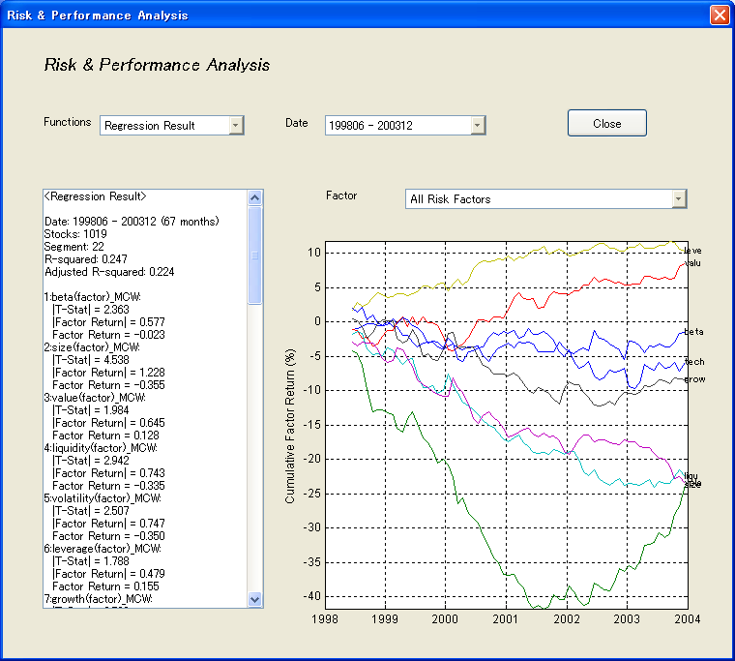
Fig. 15 Regression analysis results

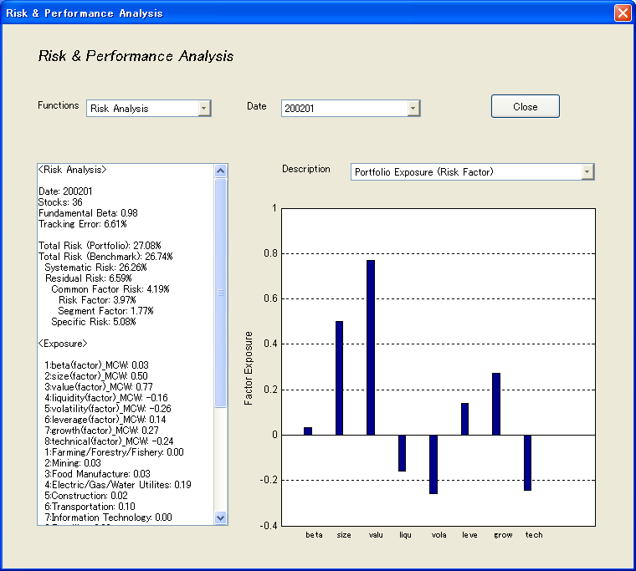
Fig. 16 Risk analysis results

(c) Display of performance analysis results
If the “Performance Analysis” is selected from the pull-down menu in the upper left of the GUI, a GUI that displays various results of a performance analysis opens. The following eight kinds of results can be selected from the pull-down menu in the upper right of the GUI.
● Cumulative Portfolio Performance
If users select “Cumulative Portfolio Performance”, a graph of portfolio and benchmark cumulative returns is displayed as shown in Fig. 17. On the left side of this window, a summary of performance-analysis results such as cumulative portfolio, benchmark returns, cumulative active return and its decomposition is displayed. In this example, an active return of about 10 % was obtained.
● Performance Analysis
As shown in Fig. 18, four graphs of systematic return, residual return, common factor return, and specific return are displayed. Users can see what term has contributed to active return. In the example shown, residual return greatly contributed to active return, meaning the selection of stocks was successful.
● Factor Contribution
A bar graph that shows the contribution of each factor to active return is displayed as shown in Fig. 19. In this graph, the unit of the vertical axis is the average monthly return during the analysis period. In this example, the contribution of factor “size” was the largest.
● Portfolio Exposure (Period Change)
Transitions of exposure to all factors are displayed as shown in Fig. 20. Users can understand what kind of factor risk was taken and is being taken now in regard to a portfolio. This graph is useful for modifying error of factor tilt strategy
● Portfolio Exposure (Period Average)
A bar graph that provides the period average of exposure for each factor is displayed (not shown). It has the same effect as the graph in Fig. 20.
● Risk Analysis
Transitions of various risks (total risk, systematic risk, and tracking error) are displayed as shown in Fig. 21. Users can grasp level of a portfolio risk.
● Total Risk & Monthly Return
Actual monthly return (star mark) and estimated monthly riskσfor a portfolio are displayed as shown in Fig. 22. By evaluating the probability that the actual return is within ±σ or ±2σ, users can verify the effectiveness of the risk model used.
● Tracking Error & Active Monthly Return
Actual monthly active return and estimated monthly tracking error σ for a portfolio are displayed (not shown). By evaluating probability that the actual active return is within ±σ or ±2σ, users can verify the effectiveness of the risk model used.
In above mentioned examples (Fig. 16 - 22), risk and performance of a sample portfolio with 36 large stocks was analyzed by using a multi-factor model constructed based on WLS. Users can understand what factors contributed to portfolio performance and can also estimate portfolio risk by using the model test tool. (An estimation error of portfolio risk was about 10% as shown in Fig. 22. However, this is not a problem on practical use.) This shows an effectiveness of the tool in a stock portfolio analysis.
4.5 Data Upload Tool
This tool (Fig. 23) is for storing exposure, covariance matrix, and specific risk required for risk analysis into the model DB. If users select the risk model for uploading the data and push the “Upload button”, the data required for risk analysis are written in the model DB.
A risk and performance system shown in Fig. 2 uses uploaded data to analyze risk and performance of stock portfolios. This system has better GUI and display functions than the model test tool.
4.6 Batch Process Tool
The window of this tool is shown in Fig. 24. This tool automatically executes a series of processes such as exposure calculation, regression analysis, covariance matrix calculation, and data upload in order to store data in a model DB. In the central edit box of the tool, the latest upload model is displayed. Once the used risk model is fixed, this tool can reduce the load on the user in constructing model DB data.

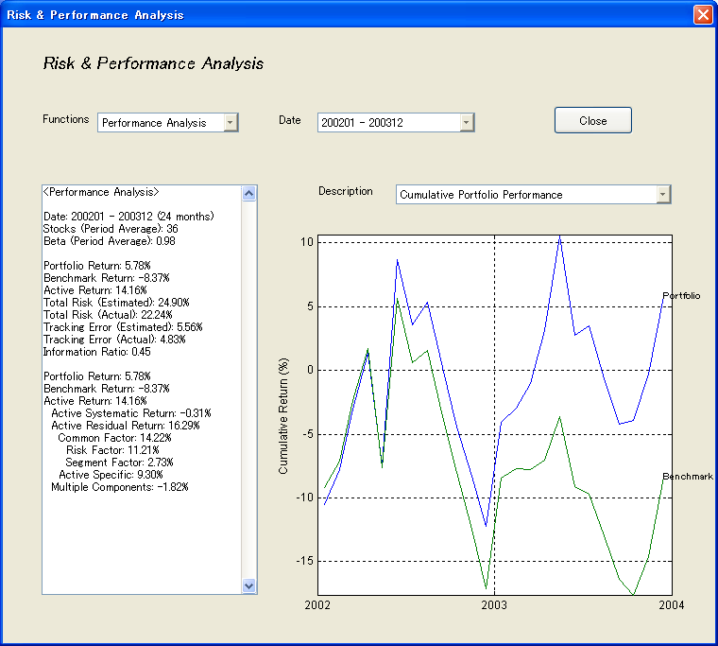
Fig. 17 Performance analysis results (Cumulative return)

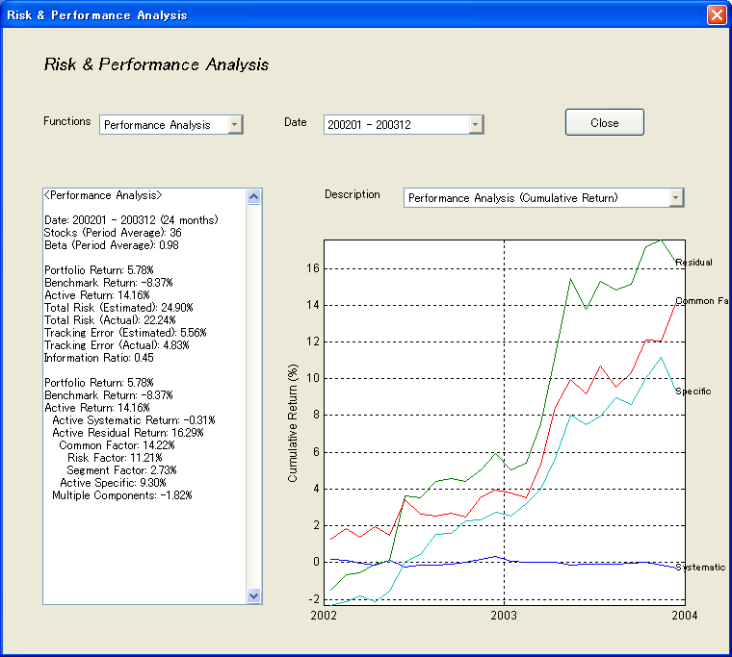
Fig. 18 Performance analysis results (Return decomposition)

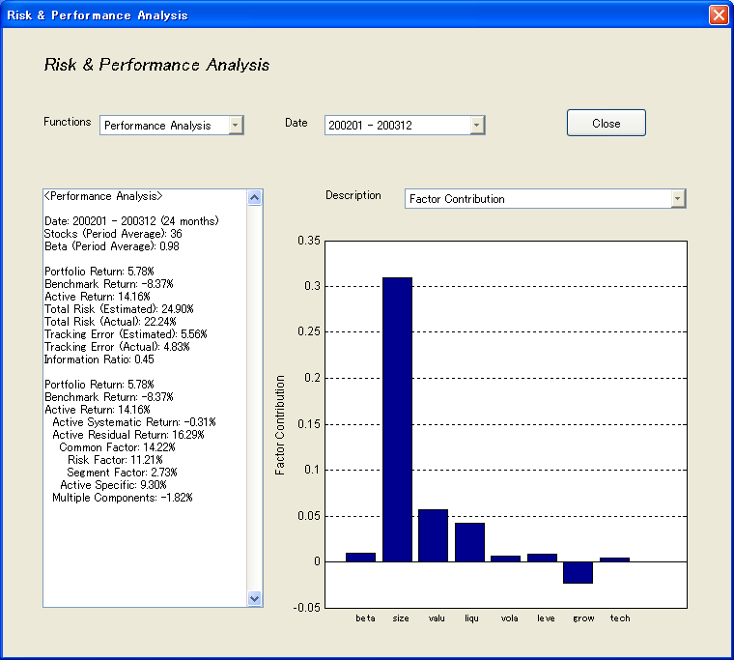
Fig. 19 Performance Analysis Results (Factor contribution)

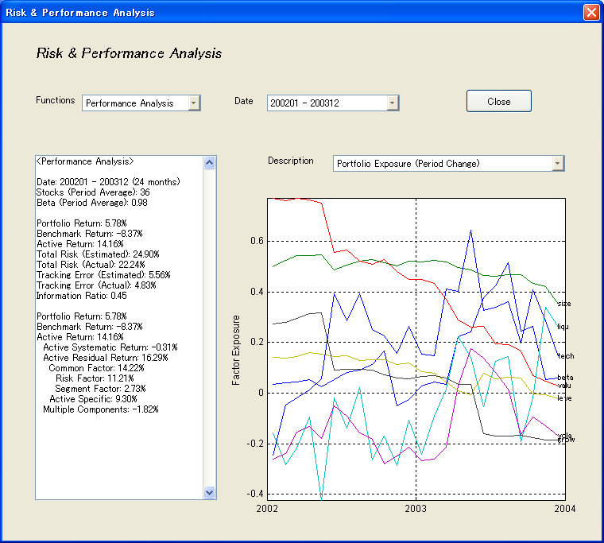
Fig. 20 Performance analysis results
(Factor Exposure Transition)

5. SUMMARY
A new tool called Risk Model Builder has been developed. The builder consists of four sub-tools for (1) exposure calculation, (2) regression analysis, (3) model testing, and (4) data uploading. Using these tools, users can build and evaluate a risk model with arbitrary factors. Detailed analysis in risk and performance can be executed by using the model test tool or the other exclusive analysis tools.

References
(1) Richard C. Grinold and Ronald N. Kahn: Active Portfolio Management, Second edition, McGraw-Hill (2000)
(2) J. Yuki: Construction of Stock Portfolio Based on Cross-sectional, Multivariate Model, Journal of JAFEE 137/163 (1999)
(3) Robert A. Haugen and Nardin L. Baker: Commonality in the Determinants of Expected Stock Return, Journal of Financial Economics (1996)
(4) BARRA International (Japan) Ltd.: Research Note (2003)
(5) Nikkei Quick Information: Selection of Risk Factors on Nikkei Portfolio Master (2002)
(6) Hitachi, Ltd.: Riskscope Operating Manual (2002)
(7) Paribas Capital Markets: Paribas Risk Model Operating Manual & Handbook
(8) Ｗilliam H. Greene: Econometric Analysis, 5th edition, Prentice Hall International Edition (2003)
(9) T. Katayama: Introduction to System Identification, Society of System, Information and Control (1994)
- A. Kogure: Econometric Analysis for Finance, Asakura Library (1998)

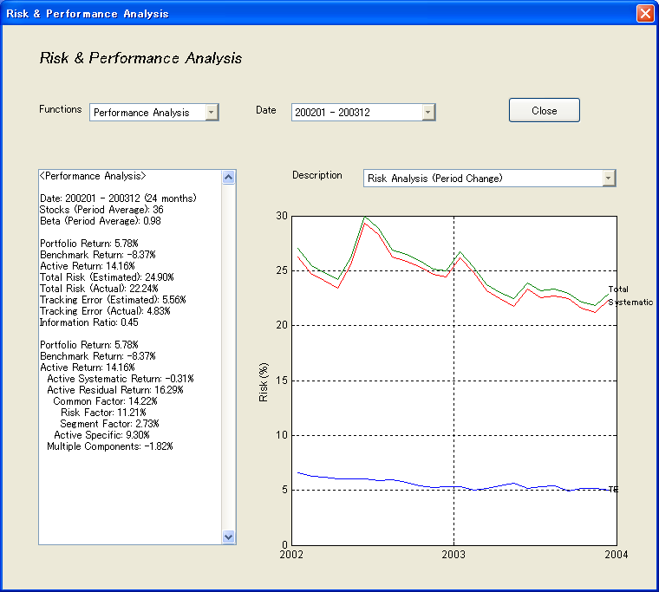
Fig. 21 Performance analysis results (Risk Transition)

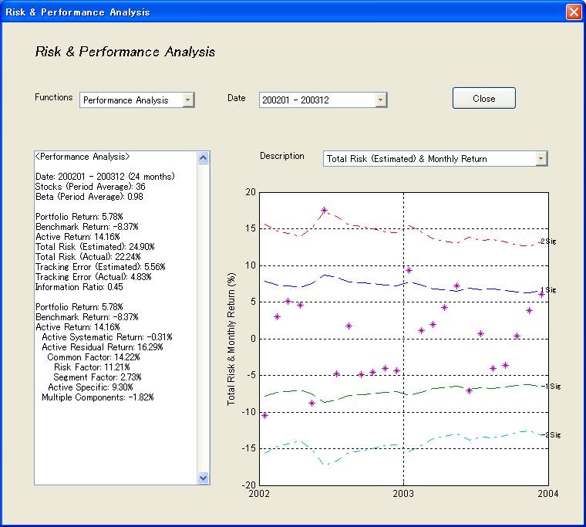
Fig. 22 Performance anlysis results
(Monthly Return & Monthly Risk)

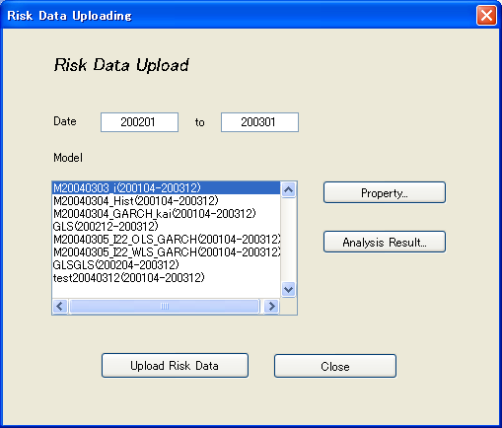
Fig. 23 Window of Data Upload Tool

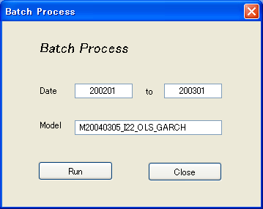
Fig. 24 Window of Batch Process Tool

Shinsuke Takahashi (Member) He received M. E. and Ph. D. degrees in engineering from Tokyo Institute of Technology in 1985 and 2000, respectively. In 1985, he joined Systems Development Laboratory, Hitachi, Ltd., where he is currently a senior researcher. His research interests include risk management system and investing technology. He has also been a visiting associate professor at Kyoto University from 2004.

Makoto Miyata He received M. E. degree from Osaka University in 1998. In 1998, he joined Systems Development Laboratory, Hitachi, Ltd., where he is currently a researcher. His research interests include financial systems for stock investing and a decision-support system. He is also Chartered Member of the Security Analysts Association of Japan.

