Collision Avoidance Control Law for Helicopters using Information Amount Feedback

Takehiro HIGUCHI*, Seiya UENO** and Kikuko IWAMA***

Utilization of helicopter in urban area is increasing because of its special flight performance. Collision avoidance guidance will play an important role in the future guidance of helicopters. All information of other aircraft is not always available for collision avoidance due to climate conditions or communication problems. Helicopter has to avoid other helicopter under such uncertain information conditions. This paper proposes controller that uses the information amount as same as physical values. The helicopter changes the flight course to increase the information amount using dynamics of information. Collision avoidance law is adopted when approaching helicopters is recognized. Avoidance is to increase the minimum distance between two helicopters. Numerical simulations show that the helicopter using the information amount avoids the approaching helicopter with safe distance.

Key Words : Guidance and control, Helicopter, Collision avoidance, Information amount feedback

- INTRODUCTION
Helicopter is useful aircraft because of its special flight performances, for example hovering in the air and taking off from small area. The utilization of helicopter has been increasing in recent years. One of examples is 'Doctor-heli', on which a medical doctor rides and saves an emergency case. The increasing number of helicopter flight leads to higher risk of accidents. Safety flight without collision accident is desired and becomes a significant criterion of guidance and control design.
The collision avoidance control has been one of the key features among the researches in field of guidance, navigation, and control. Many researches started from collision avoidance of ships¹⁾ where collision avoidance has been one of the problems due to the increasing demand for the naval transportations. Wide varieties of studies on collision avoidance are treated in fields of robots²⁾, cars³⁻⁴⁾ and satellites. Some researches treat avoidance problems with the formation control which requires the cooperative information control⁵⁻⁶⁾.
In the field of aeronautics, the Traffic alert and Collision Avoidance System⁷⁾ (TCAS) has been one of the references for the collision avoidance. TCAS exchanges the information of aircraft and advises the aircraft to avoid in vertical direction. Conflicts are always problem for collision avoidance where it is hard for the system to figure out the proper trajectory for avoidance. Frazzoli et al.⁸⁾ have given a solution for this problem using centralized conflict resolution with the decentralized aircraft preferences. Shioiri and Ueno⁹⁾ have treated collision avoidance problem in three-dimensions for safer flight of the aircraft using risk function and fuzzy logic. Gates¹⁰⁾ has proposed rule-based collision avoidance control strategies for real-time online collision avoidance. Miele et al.¹¹⁾ have proposed collision avoidance control for case of abort landing with low computational load which can be calculated by on-board computer.
As for helicopters and rotorcrafts, Bouadallah et al.¹²⁾ have simulated collision avoidance for Quadrotor using simple avoidance control law switched by threshold given by the current distance between the vehicle and the obstacle. Guerreiro et al.¹³⁾ have treated the terrain avoidance for low altitude flying helicopters using model-based predictive control and optimization.
In most of the studies that treats collision avoidance assume that the all of the information are certain, or else they consist some noise error by the sensors. In the actual cases, the lack of information caused by obstacles or bad weather can lead to accidents. Especially in the cases with the flight of the helicopters which does not require TCASs or small UAVs which has very few sensors, the vehicle cannot always obtain enough information for avoid the incoming risks. Shioiri and Ueno¹⁴⁾ treated this problem using the uncertainty parameters which parameterizes information amount that can be obtained in current condition. The collision avoidance using fuzzy logic is applied to aircraft of fixed wing type aircraft.
* Interdisciplinary Research Center, Yokohama National University, Yokohama
(E-mail: higuchi@ynu.ac.jp)
** Research Institute of Environment and Information Sciences, Yokohama National University, Yokohama
*** Nagaoka Japan Base, Schlumberger LTD., Nagaoka
(Received December 8, 2010)
Collision avoidance of helicopter under uncertain information and dynamics of information amount are not treated in any of the previous studies. This paper proposes new controller for collision avoidance under uncertain information. In the Ref. 14, the numerated uncertain information is used as reference for fuzzy logic to derive the control input. This paper directly treats dynamics of information amount and uses for feedback control.
Fig.1 Structure of the proposed controller
Focused area : S_{E}
Cleared area : S_{C}
Obstacle
V
Fig.2 Definition of ‘Focused area’ and ‘Cleared areas’
The main structure of controller is shown in Fig.1. The controller consists of two parts such as the information gathering control law and the collision avoidance control law. When the risk of collision with an intruder is high, collision avoidance is high priority. The helicopter changes the flight course and/or the velocity by the collision avoidance control law. The risk of collision, however, is calculated using the information measured by the control system. Even if the intruder is approaching, the controller judges that the flight is safe when the intruder cannot be seen. Thus, the controller must keep the information amount of the intruder in high level using dynamics of information amount. The information gathering control law provides command using the relation between the information amount of intruder and the flight course of helicopter.

- INFORMATION GATHERING CONTROL LAW

2.1 Definition of information amount
It can be said that a helicopter is in a safe flight when there is no aircraft in front of the helicopter. The triangular region in front of the helicopter is used as the area to obtain the information amount. This area is call as ‘Focused area’ in this paper. Fig.2 shows a conceptual figure. The figure show the case when the obstacle is in the focused area. The shadow area behind the obstacle cannot be seen from the helicopter. The information from the other area, the white area in Fig.2, can be used for the controller. This area is called as ‘Cleared area’ in this paper. Focused area and the cleared area are S_{E} and S_{C} as shown in Fig. 2. The following value represents the safety of helicopter.
$I_{L}≡S_{C}/S_{E}$ (1)
This ratio is called ‘Information of Localization’ in this paper. The value represents the amount of information obtained by the helicopter. The information gathering controller is designed to increase this value higher than the requirement.

2.2 Controller design
Design of information gathering control law is derived using a model shown in Fig.3. Focused area depends on the speed and direction of helicopter, so the distance x_{P} is a function of velocity. The angle θ_{P} also depends on the level

of safety. Focused area is given as follows.
$S_{E}=x_{P}^{2}⋅\text{tan}θ_{P}$ (2)
The shadow area S_{B} cannot be seen from the helicopter. It is assumed as the following equation.
$S_{B}=\frac{1}{2}\left(x_{P}^{2}−x_{A}^{2}\right)⋅\left(\text{tan}θ_{P}−\text{tan}θ_{A}\right)$ (3)
where $\text{tan}θ_{A}=y_{A}/x_{A}$
x_{A} and y_{A} are relative coordinate in the body fixed frame as shown in Fig.(3)b. The shadow area is approximated as trapezoid area for the difference with the actual value is small. The derivative of the shadow area is mainly used to build the controller. The relation between focused area, cleared area, and shadow area is as follows.
$S_{C}=S_{E}−S_{B}$ (4)
The time derivatives of x_{A} and y_{A} are given as follows.
$\frac{d}{\text{dt}}\left(\begin{matrix}x_{A} \\ y_{A}\end{matrix}\right)=\left(\begin{matrix}y_{A} \\ −x_{A}\end{matrix}\right)ω_{0}−\left(\begin{matrix}1 \\ 0\end{matrix}\right)V_{0}$ (5)
Fig.3 Model for controller design : There is an obstacle in the focused area
y_{G}
x_{G}
Obstacle
V
a) Earth fixed coordinate (x_{G},y_{G})
b) Body fixed coordinate (x_{B},y_{B})
A(x_{A}, y_{A})
θ_{A}
θ_{P}
S_{B}
x_{P}

y_{B}
x_{B}
V
Obstacle
where ω₀ and V₀ are angular velocity and velocity of the helicopter, respectively. ω₀ is positive in counterclockwise direction. To derive the dynamical property of information amount, time derivative of the information localization is derived.
$\frac{{\text{dI}}_{L}}{\text{dt}}=\frac{S_{B}{\overset{˙}{S}}_{E}−{\overset{˙}{S}}_{B}S_{E}}{S_{E}^{2}}$ (6)
S_{B} and S_{E} are given in Eqs.(2) and (3). It is necessary to define the x_{P} and θ_{P} of the focused area in order to derive the time derivative. The distance of focused area x_{P} is proportional to the velocity of helicopter V₀.
$x_{P}=V_{0} Δt$ (7)
where Δt is a constant and the unit is time. This shows that the helicopter moves the distance of x_{P} in the period of Δt. The angle θ_{P} is constant. Thus the helicopter focuses wide region in case of high speed.
The following time derivatives are derived.
$\begin{aligned}\frac{d}{\text{dt}}\left(\begin{matrix}S_{B} \\ S_{E}\end{matrix}\right)=\left(\begin{matrix}A & B \\ D & 0\end{matrix}\right)\left(\begin{matrix}{\overset{˙}{V}}_{0} \\ V_{0}ω_{0}\end{matrix}\right)+\left(\begin{matrix}C \\ 0\end{matrix}\right) \\ \left(\begin{matrix}A & B \\ D & 0\end{matrix}\right)\left(\begin{matrix}a_{x} \\ a_{y}\end{matrix}\right)+\left(\begin{matrix}C \\ 0\end{matrix}\right)\end{aligned}$ (8)
where
$$A=V_{0}(Δt)^{2}\left(\text{tan}θ_{P}−\text{tan}θ_{A}\right)$$
$$\begin{aligned}B=[−x_{A}y_{A}\left(\text{tan}θ_{P}−\text{tan}θ_{A}\right) \\ +\frac{1}{2}\left(x_{P}^{2}−x_{A}^{2}\right)\left(1+{\text{tan}}^{2}θ_{A}\right)]/V_{0}\end{aligned}$$
$$C=\left[x_{A}^{2}\left(\text{tan}θ_{P}−\text{tan}θ_{A}\right)−\frac{1}{2}\left(x_{P}^{2}−x_{A}^{2}\right)\text{tan}θ_{A}\right]V_{0}/x_{A}$$
$$D=2V_{0}(Δt)^{2}\text{tan}θ_{P}$$
a_{x} and a_{y} are horizontal acceleration caused by the lift of main rotor in the body-fixed frame. Substituting Eq. (8) into Eq.(6), the time derivative of I_{L} is given.
$\frac{{\text{dI}}_{L}}{\text{dt}}=E⋅a_{x}+F⋅a_{y}+G$ (9)
where
$\begin{aligned}E=\left(S_{B}D−S_{E}A\right)/S_{E}^{2} \\ F=−B/S_{E} \\ G=−C/S_{E}\end{aligned}$
Therefore, the information amount of safety can be changed by a_{x} and a_{y}. This shows that the direction of lift of the main rotor changes the information amount.
The information gathering control law is required to keep the information amount higher than the specified value. This value is called 'Information acquisition requirement', I_{R}. Thus the shortage of information amount is defined in the following equation.
$I_{E}=\left\{\begin{matrix}I_{R}−I_{L} & & (I_{R}>I_{L}) \\ 0 & & (I_{R}≤I_{L})\end{matrix}\right.$ (10)
In the case when I_{L} is less than I_{R}, the controller is required to increase I_{L}. On the other hand, in the case of I_{L} is greater than I_{R}, the high decreasing rate of I_{L} is not desired. Therefore the following control law satisfies the both cases.
${\overset{˙}{I}}_{L}≥{\left({\overset{˙}{I}}_{L}\right)}_{\text{min}}$ (11)
where ${\left({\overset{˙}{I}}_{L}\right)}_{\text{min}}=k_{E}\left(I_{R}−I_{L}\right)$
k_{E} is a feedback gain. The left hand side of Eq.(11) is given in Eq.(9). Equation (9) has two input variables, a_{x} and a_{y}. Thus the Euclidean norm of input vector is chosen.
${\left(a_{x}\right)}_{I}=E⋅u_{N}, {\left(a_{y}\right)}_{I}=F⋅u_{N}$ (12)
Fig.4 Definition of TCPA and RCPA
in body fixed frame of helicopter
where
$u_{N}=\left(k_{E}(I_{R}−I_{L})−G\right)/\left(E^{2}+F^{2}\right)$
This control law uses the same feedback gain in the cases of I_{R}>I_{L} and I_{R} < I_{L}.
The helicopter is required to keep the desired velocity V_{R} and direction ψ_{R} when the information amount satisfies the requirement. In this case, the following feedback law is used.
${\left(a_{x}\right)}_{D}=k_{V}\left(V_{R}−V_{0}\right), {\left(a_{y}\right)}_{D}=k_{ψ}\left(ψ_{R}−ψ_{0}\right)V_{0}$ (13)
where k_{V} and k_{ψ} are feedback gains and ψ_{R} is directional angle. Both k_{V} and k_{ψ} are set as 0.2[1/s] from time constant to be 5.0[s] for the course keeping control in this paper. The values are selected to have smooth return from the avoidance.
Finally, the information gathering control law is given as follows.
i) if $E⋅{\left(a_{x}\right)}_{D}+F⋅{\left(a_{y}\right)}_{D}+G≥{\left({\overset{˙}{I}}_{L}\right)}_{\text{min}}$
then $a_{x}={\left(a_{x}\right)}_{D}, a_{y}={\left(a_{y}\right)}_{D}$ (14)
ii) if $E⋅{\left(a_{x}\right)}_{D}+F⋅{\left(a_{y}\right)}_{D}+G<{\left({\overset{˙}{I}}_{L}\right)}_{\text{min}}$
then $a_{x}={\left(a_{x}\right)}_{I}, a_{y}={\left(a_{y}\right)}_{I}$ (15)
The I_{L} in the inequality conditions are given in Eq. (11). From here on, the control law is called Information Amount FeedBack (IAFB) for it feeds back the information amount as one of the parameters for information gathering.

- COLLISION AVOIDANCE CONTROL LAW

The risk of collision is described numerically to design control law. Two values are introduced in this paper. One is ‘Range to Closest Point to Approach (R_{CPA})’, which is the minimum range between two aircraft when their present velocities and directional angles are kept. The closest point is shown in Fig.4. This value indicates the future risk of collision. The other is ‘Time to Closest Point to Approach (T_{CPA})’, which is time to the range between two aircraft is R_{CPA}. Even if R_{CPA} is small, it is not necessary to avoid quickly when T_{CPA} is large. The collision avoidance control law is derived from the combination of two risk functions.
R_{CPA} and T_{CPA} are provided using the relative position, x_{R}, y_{R}, x_{C}, and y_{C}, velocity, u_{R} and v_{R}, in the body fixed coordinate shown in Fig.4.
$R_{\text{CPA}}=\sqrt{x_{C}^{2}+y_{C}^{2}}$ (16)
$T_{\text{CPA}}=−\left(x_{R}u_{R}+y_{R}v_{R}\right)/\left(u_{R}^{2}+v_{R}^{2}\right)$ (17)
The risk function is defined as the following equation.
$ϕ≡R_{0}^{2}/\left(R_{0}^{2}+R_{\text{CPA}}^{2}\right)$ (18)
where R₀ represents the safety range, this is constant distance between the aircraft which is set as safety requirement by the users. Collision will occur when ϕ =1. When R_{CPA} is equal to R₀, ϕ =0.5. The collision avoidance control law is designed to reduce ϕ less than 0.5 in a period of T_{CPA}. Thus the proposed collision avoidance control law satisfies the following equation.
$\overset{˙}{ϕ}=−ϕ/T_{C}$ (19)
Fig.5 Definition of initial conditions for numerical calculation : The proposed collision avoidance controller is mounted on the evader
T_{C} is time constant that is derived from the following requirement.
$T_{C}=−T_{\text{CPA}}/\text{ln}\left(2ϕ_{0}\right)$ (20)
where ϕ₀ is the initial value of risk function. On the other hand, the time derivative of risk function is given as follows.
$\overset{˙}{ϕ}=−2ϕ(x_{C}{\overset{˙}{x}}_{C}+y_{C}{\overset{˙}{y}}_{C})/\left(R_{0}^{2}+R_{\text{CPA}}^{2}\right)$ (21)
The left hand side of Eq.(21) is given in Eq.(19). The control law can be derived. However, the requirement is described in only one equation. The number of input variables a_{x} and a_{y}, is two. Thus the Euclidean norm of input variables is used to derive the control law.
$a_{x}=c_{0}c_{x}, a_{y}=c_{0}c_{y}$ (22)
where
$$c_{0}=R_{0}^{2}/\left(2{ϕT}_{C}(c_{x}^{2}+c_{y}^{2})\right)$$
c_{x} and c_{y} are functions of the relative positions, relative velocities and the velocity of helicopter. These are derived from following equations. The R_{CPA} in the body fixed frame is,
$\begin{aligned}x_{C}=v_{R}\left(x_{R}v_{R}−y_{R}u_{R}\right)/\left(u_{R}^{2}+v_{R}^{2}\right) \\ y_{C}=−u_{R}\left(x_{R}v_{R}−y_{R}u_{R}\right)/\left(u_{R}^{2}+v_{R}^{2}\right)\end{aligned}$ (23)
and the time derivative is,
$\frac{d}{\text{dt}}\left(\begin{matrix}x_{C} \\ y_{C}\end{matrix}\right)=\left(\begin{matrix}p_{x} & q_{x} \\ p_{y} & q_{y}\end{matrix}\right)\left(\begin{matrix}−1 & v_{R}/V_{0} \\ 0 & −u_{R}/V_{0}−1\end{matrix}\right)\left(\begin{matrix}a_{x} \\ a_{y}\end{matrix}\right)$ (24)
where
$p_{x}=\left[−2x_{R}u_{R}v_{R}^{2}+y_{R}v_{R}\left(u_{R}^{2}−v_{R}^{2}\right)\right]/{\left(u_{R}^{2}+v_{R}^{2}\right)}^{2}$
$q_{x}=\left[2x_{R}u_{R}^{2}v_{R}−y_{R}u_{R}\left(u_{R}^{2}−v_{R}^{2}\right)\right]/{\left(u_{R}^{2}+v_{R}^{2}\right)}^{2}$
$p_{y}=\left[2y_{R}u_{R}v_{R}^{2}+x_{R}v_{R}\left(u_{R}^{2}−v_{R}^{2}\right)\right]/{\left(u_{R}^{2}+v_{R}^{2}\right)}^{2}$
$q_{y}=\left[−2y_{R}u_{R}^{2}v_{R}−x_{R}u_{R}\left(u_{R}^{2}−v_{R}^{2}\right)\right]/{\left(u_{R}^{2}+v_{R}^{2}\right)}^{2}$

From these equations, the c_{x} and c_{y} for Eq.(22) is calculated as follows.
$\begin{aligned}c_{x}=−(p_{x}x_{C}+p_{y}y_{C}) \\ c_{y}=−\left(v_{R}/V_{0}\right)(p_{x}x_{C}+p_{y}y_{C})−\left(\left(v_{R}/V_{0}\right)+1\right)(q_{x}x_{C}+q_{y}y_{C})\end{aligned}$ (25)

- NUMERICAL SIMULATIONS

Numerical simulation is performed to show the effect of the information amount feedback. Fig.5 shows the simulation condition of numerical calculation. The helicopter mounted with the avoidance controller is flying from the left to right parallel to x-axis. This helicopter is called as 'evader'. The initial x-coordinates are same at x(0) =-150[m] and the initial y-coordinates are different in each simulation cases. The velocity of the evader is 10[m/s] at the beginning of the simulation. The other helicopter, called as 'intruder', is coming downward from (40, 50) [m]. The intruder keeps its course in constant velocity at 10[m/s]. There is obstacle for information gathering on the positive y-axis. The evader cannot see the intruder at the initial position. The focused area of evader is defined as a triangle area in front of the evader shown in Fig.3. The corn angle of triangle is constant during the flight. The distance from the evader to the far side of triangle depends on the velocity of evader. In this paper, x_{P} is set as 120[m] and θ_{P} is set as 45[deg] for the vehicle is moving at 10[m/s] at initial condition and focuses on the region within 12[s].
Input variables in two cases are plotted in Fig.6. The initial conditions of evader are y(0)=-20[m] and y(0)=-30[m], respectively. In both cases, the input from IAFB shows similar tendency, then moves on the emergency avoidance with large input after the intruder is found. The directions of the acceleration shows opposite in two cases where one decelerate and turns left, and the other accelerates and turns right.
The trajectories of five different cases are plotted in Fig.7. The trajectories of intruder are also plotted. Diamond symbols show the positions at every second. The red symbols represent the position of intruder when they are at minimum distance from the intruder. The results show that the velocities of evader are reduced with larger deceleration when the evader flies nearer the obstacle. The trajectories separate into two groups after the evader passes around x=-50[m], where the evader finds the intruder. Group-A is that the evader makes left turn and decelerates. The evader goes behind the intruder to avoid the collision. The cases y(0)=0[m] to -20[m] belongs to this group. The other group-B is that the evader makes farther right turn and accelerates. The evader escapes from the intruder. The cases y(0)=-30[m] and beyond belongs to this group. The maneuvers shown in the simulations are very similar to the action of human during walking or driving. Human makes decision and changes the velocity and the direction for safety from huge number of experiences. The proposed controller provides the similar trajectories.
a) Acceleration in x_{B}-direction a_{x}
b) Acceleration in y_{B}-direction a_{y}

Fig.6 Input variables of the evader for two cases. All accelerations are constrained as less than 1.0[m/s²]
Fig.7 Trajectories of evader from five initial conditions : Diamond symbols are plotted at every seconds
Fig.8 Time history of risk function for different initial conditions

Fig.8 shows the time history of ϕ in different initial conditions. In all cases, the risk enlarges when the intruder is found. The timing of the detection differs by the initial position of the evader. After the intruder is found, we can see that the evader tries to lower the risk in order to avoid the intruder. The value lowers after the intruder is out of sight, the evader goes back to the course keeping control. Fig.9 shows the time history of I_{L} in different initial conditions. In all of the cases, the I_{R} is set as 0.9. At t=3[s], the obstacle approaches the focused zone and I_{L} starts to decrease. The IAFB keeps the I_{L} larger than I_{R}. In the latter half of the control, the collision avoidance control makes the obstacle to appear in focused area which makes the I_{L} decrease in t=18[s]. The collision avoidance control has advantage to IAFB so the I_{L} has possibility to be lower than I_{R} when avoiding the intruder.
Fig.10 shows the trajectory of the evader when IAFB is not used. Comparing the results with the case with IAFB shown in Fig.7, the evader keeps the trajectory and velocity till it actually finds the intruder. The evader starts the avoidance slower than the cases with IAFB. The red symbols show that evader has made safer flight especially in group-A where the IAFB works more to obtain information.
Fig.11 Minimum distance between the evader and the intruder (IAFB : Information Amount FeedBack)

Fig.9 Time history of information of localization for different initial conditions
Fig.10 Trajectories of evader without IAFB. The evader keeps straight course till the intruder is found
Fig.11 shows the minimum distance between the evader and the intruder. This distance shows the amplitude of safety directly. Black circles show the results using the proposed controller with IAFB. White circles show the results of using only the collision avoidance controller without IAFB. The minimum distance increases more than twice in the worst initial conditions. This results shows that the proposed controller is effective when the information amount does not satisfy the safety.

- CONCLUSIONS

This paper proposes information amount feedback controller combined with the collision avoidance control system. The information amount feedback uses information as one of the physical value to be treated in collision avoidance system. The results of numerical simulations show that the proposed controller helps the helicopter to collect the information when there is region that information is uncertain and tries to obtain safer conditions. As result, controller increases the distance between the evader and the intruder. The motion of the helicopters shows similar trajectories to that of humans to obtain safe margin to gain information when they do not have enough information. The controller can be applied to various systems for collision avoidance.

References
- M. D.Ciletti, A. W. Merz and S. Takushoku : Collision Avoidance Maneuver for Ships, Navigation –Japan Institute of Navigation-, 54, 83/89 (1977)
- T. Fukuda and N. Kubota : An Intelligent Robotic System Based on a Fuzzy Approach, Proc. of the IEEE, 87-9, 1448/1470 (1999)
- T. Hiraoka, M. Tanaka, H. Kumamoto, T. Izumi and K. Hatanaka : Collision Risk Evaluation Index Based on Deceleration for Collision Avoidance (First Report) : Proposal of a new index to evaluate collision risk against forward obstacles, Review of Automotive Engineering, 30-4, 429/437 (2009)
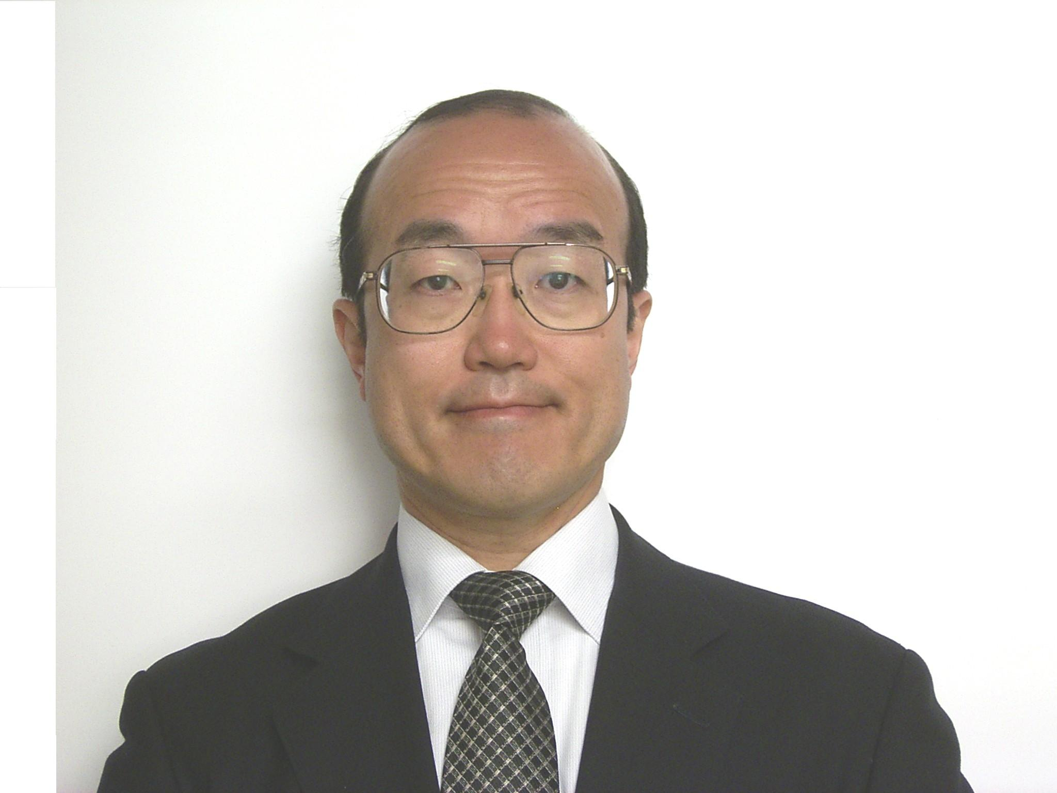
- T. Hiraoka, M. Tanaka, S. Takeuchi, H. Kumamoto, T. Izumi and K. Hatanaka : Collision Risk Evaluation Index Based on Deceleration for Collision Avoidance (Second Report) : Forward obstacle warning system based on deceleration for collision avoidance, Review of Automotive Engineering, 30-4, 429/447 (2009)
- G. L. Slater, S. M. Byram and T. W. Williams : Collision Avoidance for Satellites in Formation Flight, Journal of Guidance, Control, and Dynamics, 29-5, 1140/1146 (2006)
- D. M. Stipanovic, P. F. Hokayem, M. W. Spong, D. D. Salijak : Cooperative Avoidance Control for Multiagent Systems, Journal of Dynamic Systems Measurement and Control –Transactions of the ASME, 129-5, 699/707 (2007)
- Introduction to TCAS II, U.S. Department of Transportation, Federal Aviation Administration (1990)
- E. Frazzoli, Z. H. Mao, J. H. Oh and E. Feron : Resolution of Conflicts Involving Many Aircraft via Semidefinite Programming, Journal of Guidance, Control, and Dynamics, 24-1, 79/86 (2001)
- H. Shioiri and S.Ueno : Three-dimensional Collision Avoidance Control Law for Aircraft using Risk Function and Fuzzy Logic, Trans.of JSASS, 46-154, 253/261 (2004)
- D. J. Gates : Properties of a Real-Time Guidance method Preventing a Collision, Journal of Guidance Control and Dynamics, 32-3, 705/716, (2009)
- A. Miele, T. Wang, J. A. Mathwig and M. Ciarcia : Collision Avoidance for an Aircraft in Abort Landing : Trajectory Optimization and Guidance, Journal of Optimization Theory and Applications, 146-2, 233/254 (2010)
- S. Bouadballah, M. Bechker, V. de Perrot, and R. Siegwart : Toward Obstacle Avoidance on Quadrotors, Proc. of 12th DINAME, 1/10(2007)
- B. Guerreiro, C.Silvestre, and R. Cunha : Terrain Avoidance Model Predictive Control for Autonomous Rotorcraft, Proc. of 17th World Congress of IFAC, 1076/1081 (2008)
- H. Shioiri and S.Ueno : Collision Avoidance Control Law for Aircraft under Uncertain Information, Trans.of JSASS, 47-157, 209/215 (2004)
- K. Iwama : Study on Collision Avoidance Control Law using Information Amount Feedback, Master Thesis of Yokohama National University (2008)

Takehiro Higuchi
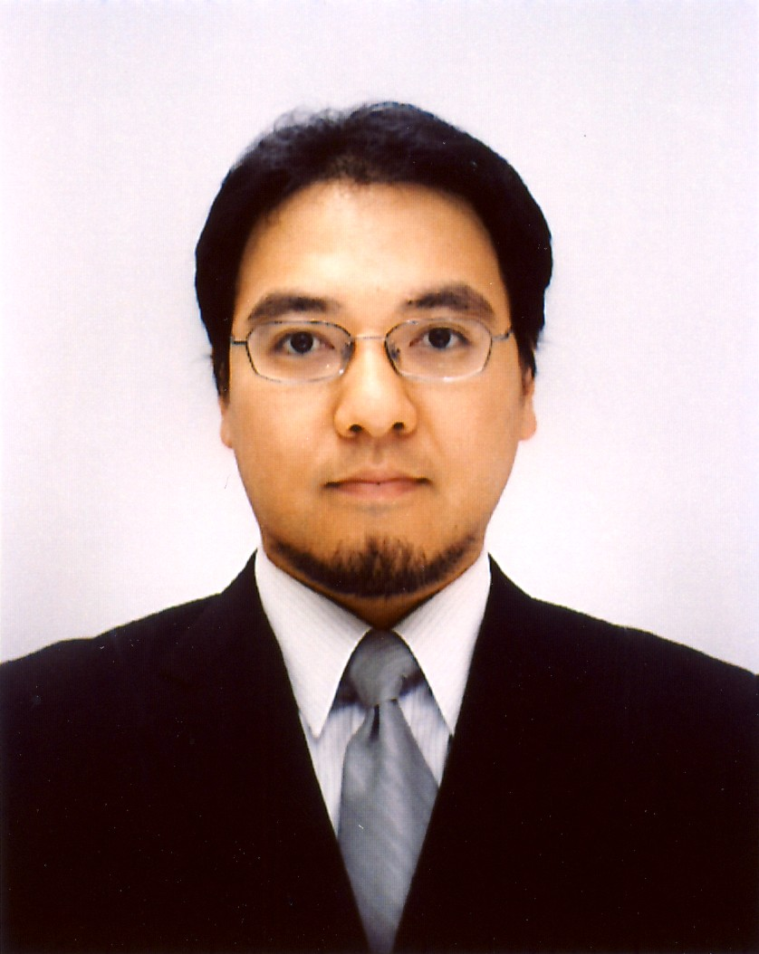
He received the B.E., M.E., and Ph.D. degrees from Yokohama National University in 2000, 2002, and 2005, respectively. He has worked as assistant professor at Yamaguchi University from 2005 to 2007, and has been working as assistant professor at Yokohama National University from 2007. His research interests are optimal control and system design of aerospace systems.

Seiya Ueno
He received the B.E., M.E., and Ph.D. degrees in aeronautical engineering from the university of Tokyo in 1980, 1982, and 1985, respectively. He joined the Division of Space Development, Toshiba corporation in 1985. In 1988, he moved to Yokohama National University, where he has been a professor since 2002. His major research fields are applications of optimal control in aerospace engineering.

Kikuko Iwama

She received the B.E. and M.E. degrees from Yokohama National University in 2006 and 2008, respectively. She is working as field engineer of Drilling and Measurement division at Schlumberger LTD. Her current interest is designing the tool that works in critical environment like thousands of meters below the ground.

